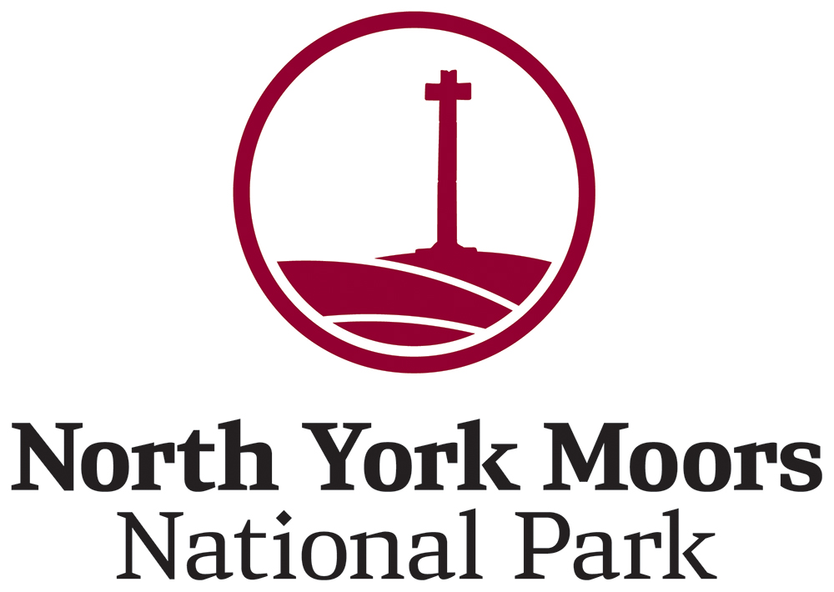

Job description
Post of Young Volunteer Award Creative
Contract – 37 hours from November 2024 – March 2025
Recreation & Wellbeing Department
Responsible to Youth Engagement Officer
Work base – Danby Lodge National Park Centre

Purpose
The purpose of the Young Volunteer Award is to support participants in the National Park’s Young Ranger and Youth+ programmes in building competencies and green skills. This is a development role. The post holder will have relevant support and guidance from the Youth Engagement Officer to develop skills.

Main duties and responsibilities
- To develop and create an inclusive Young Volunteer Award which will engage and inspire young people to develop their knowledge and skills about the natural world. To be focussed on ages 11 – 25 and which is easy to follow and shows progress.
- To consult with Young Rangers and Youth+ Members on the award before final amendments.
- To consult with the National Park’s Graphic Designer to work up the Young Volunteer Award.
- Follow the National Park Authority's policies on Health and Safety and on Working with Children and Young People.
Training
All necessary training and outdoor learning resources will be provided. Staff will also be expected to acquire at least a basic level of knowledge in all aspects of the National Park and how it is managed.

Person specification
Skills & Experience | Essential | Desirable
Any relevant voluntary experiences in any role |  | yes
A strong amount of passion and enthusiasm for the national park and its management plan |  | yes
Relevant communication skills – a strong willingness to develop |  | yes
Confidence in taking roles of responsibility |  | yes
Confidence in developing outdoor learning resources for use with a wide range of age groups and sharing this creativity with a wide range of age groups |  | yes

Personal qualities | Essential | Desirable
Be able to manage time effectively – a strong willingness to develop |  | yes
Adaptable, willingness to learn and a can do attitude towards the role |  | yes
A friendly, cheerful disposition and able to communicate at different levels - with young children, teenagers, leaders and colleagues. |  | yes
Good team working skills – a strong willingness to develop |  | yes
To have passion, enthusiasm and a decent background of national parks or nature based subjects e.g trees, wildlife |  | yes
Able to work some evenings and weekends – to have adaptable working days |  | Yes

Post of Youth Volunteer Award Creator
The new post will be from Sep – Mar totalling 37 hours.

Pay
The salary is £858.00 total for the 37 hours with up to £30 per day for travel

Values
Our Values reflect the way in which we all deliver our work and interact with people. The Values are visible in our work, and we hold each other to account for them, celebrate when we demonstrate them, and use them to help us make decisions and consider our priorities.
- Proud: We are proud to be a part of an organisation that conserves, enhances and champions this spectacular landscape – each of our roles makes this possible.
- Professional: We are doers, enablers, inspirers - we uphold the highest professional standards to bring about positive change for the National Park.
- Welcoming: Inclusivity and empathy are at the heart of who we are and what we represent - the National Park is a place for all.
- Collaborative: We work positively and proactively with others to achieve our shared vision of the North York Moors.

Conditions of service
The appointment is based at the Danby Lodge National Park Centre.
The postholder will be eligible to join the Local Government Pension Scheme. Full details of the LGPS, together with information about how to join, will be sent to the successful applicant.


