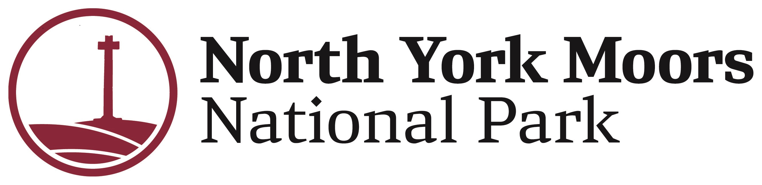

North York Moors National Park Authority

Accessibility grant

Application form 2023/24
Making your tourism business more inclusive to disabled guests or those with accessiblity requirements will introduce you to an underserved and growing market. Used in conjuction with VisitEngland’s Accessible and Inclusive Tourism Toolkit for Businesses, our accessibilty grant scheme is there to help micro, small and medium tourism businesses make small improvements to your offering, to start your journey towards a more inclusive business meeting the needs of disabled visitors.
Subject to approval, the grant of up to £1,000 towards the cost of accessibility improvements is available to all businesses and community groups in the North York Moors, Coast & Hills LEADER boundaries 2008 - 2013 . Match funding is not required. Priority will be given to applicants actively participating in the North York Moors Tourism Businesses Network.
If you are seeking to make more substantial accessibility changes to your business, and require a larger financial contribution, funding is available through our Local Business Tourism Contribution fund. This scheme will require match funding.
You must read the ‘Guidance for Applicants’ before completing this form.

Applicant details
Date: …………………………………………………………………………………………………………………………
Contact name: ………………………………………………………………………………………………………………………...
Organisation/business(es): ……………………………………………………………………………………………………………………….
Address: ……………………………………………………………………………………………………………………….
Tel no: ……………………………………………………………………………………………………………………….
Email: ………………………………………………………………………………………………………………………..
Website: ……………………………………………………………………………………………………………………….
Project title: ………………………………………………………………………………………………………………………..
Project location: …………………………………………………………………………………………………………………………
What is your formal status?
Sole trader/ partnership
Limited company
Voluntary group/not for profit organisation/registered charity
Collaborative group (specify below) ....……………………......................
Other (specify) ....…………………….................................................................
Are you VAT registered? If yes, please provide VAT number………………………………...............

Accessibility project
- Have you undertaken a recent accessibility audit and if so what were the recommendations? If you haven’t received an accessibility audit is this something you would like more information on?
………………………………………………………………………………………………………………………………………………………………………………………………………………………………………………………………………………………………………………………………………………………………………………………………………………………………
- Please provide a brief description of your proposed accessibility project including the improvements you wish to make. Outline which elements of the project you are asking to be supported through this funding. Please include a brief description about the accessibility measures you wish to incorporate and how these improvements will help your visitors and your organisation.
………………………………………………………………………………………………………………………………........................................................................................................................................................................................................................................................................................................................................................................................................
- Please indicate how your project will improve the health and wellbeing of visitors.
………………………………………………………………………………………………………………………………………………………………………………………………………………………………………………………………………………………………………………………………………………………………………………………………………………………………

Project finances
Has your business received public funding in the past three years? If yes, provide details of amount of contribution received (or expected to if yet to claim) and from whom.
No
Yes - How much: £…………………………………..
From whom: …………………………………………………………………………………………………………………………..
Example of budget table
Cost breakdown | £
Accessibility audit | £1000
Wheelchair ramp | £250
Shower Chair | £250
Handrail | £100
Total project cost | £2000

Budget table for completion by applicant
Please list the expenditure for the project in the Budget Tables below (you must provide quotes, see Guidance for Applicants). Add extra lines in the table where needed.
- Maximum award is £1000.

Item  Include item and company name | Item cost (£)
Total project cost | £
- Please detail what permissions are needed and provide copies if applicable. Please note it is your responsibility to get these permissions. We do not fund projects that require planning permission prior to permission being granted.
………………………………………………………………………………………………………………………………………………………………………………………………………………………………………………………………………………………………………………………………………………………………………………………………………………………………
- Please state expected project completion date (must be before 31 March 2024)
………………………………………………………………………………………………………………………………….
I declare that I have been authorised by the above organisation to complete this application form and that the information provided is correct to the best of my knowledge, and that if any of the information changes I will inform the North York Moors National Park Authority immediately.
Signature………………………………………………………………………………………………………………………
Name…………………………………………………………………………………………………………………………....
Date………………………………………………………………………………………………………………………………
Please return this application form and supporting information to Sharron Sumner
By email: s.sumner@northyorkmoors.org.uk
By post:Sharron Sumner, North York Moors National Park Authority, The Old Vicarage, Bondgate, Helmsley, York YO62 5BP
Please include quotes, photographs, maps, a copy of your constitution (aims and membership) for voluntary groups/charities etc., or any other documentation, which you feel would help support your application.
Any data you provide on this Form will be held by the North York Moors National Park Authority under the Data Protection Act 1998 and will be used only for the administration and management of NPA contributions.

