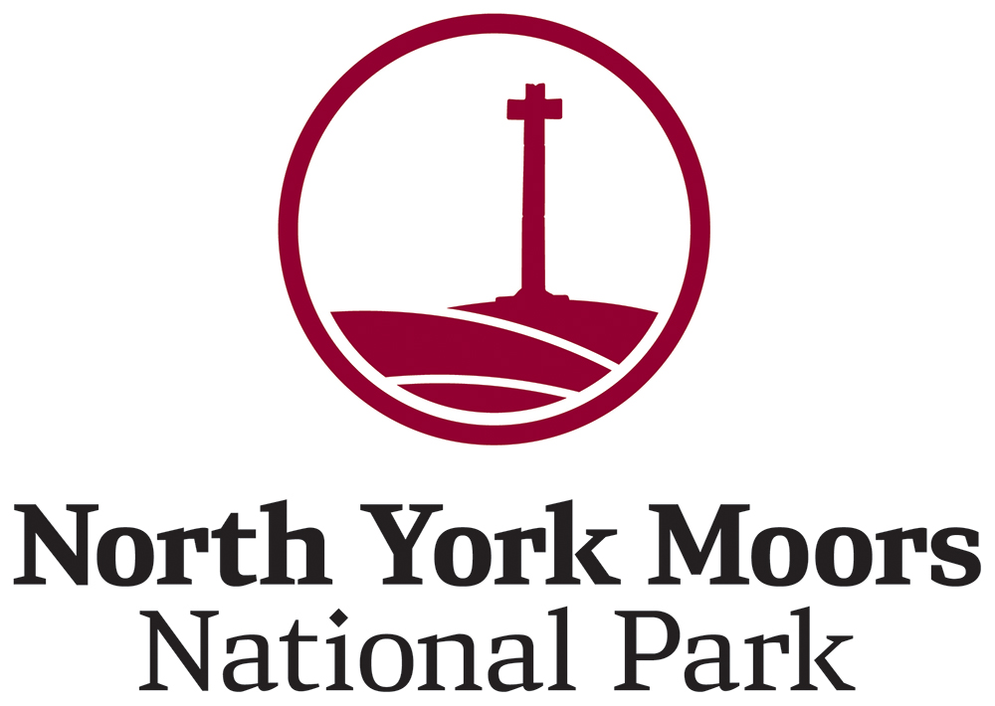

Discharge of conditions
There are often conditions attached to planning decisions that need further details to be submitted and approved by the Authority at certain stages of the development. This process is called ‘discharge of conditions.’
If your planning permission has been granted, the decision notice will state any conditions that need to be discharged before development can begin and what details must be submitted to do so. If you start work without discharging conditions, you are at risk of enforcement action and of invalidating your permission.
There are four main types of condition, the list below details if and when they require Local Authority approval:
Pre-commencement conditions: These conditions need to be formally discharged prior to construction and or development starting on site
Pre-occupation/use conditions: These conditions need to be formally discharged prior to the development being occupied or first brought into use
Conditions requiring details: Some conditions require specific details to be submitted to the Authority prior to an element of the scheme being carried out i.e. window details.
Standard Conditions: These do not require formal discharging; however, they must be complied with.
Please note that under current planning legislation, there is a fee payable for discharging conditions. This does not apply to conditions on listed building consents, only planning permission.
The current fee schedule is also available on the Authority’s website (www.northyorkmoors.org.uk/planning/planning-applications-and-planning-advice/planning-applications/forms-and-guidance)
In order to satisfy the requirements of the condition(s) you should, in writing, enclose the necessary information, relevant fee, specify the site address and set out the condition(s) you wish to discharge.
Alternatively, you may wish to complete the application form which is available on the Authority’s website. (www.northyorkmoors.org.uk/planning/planning-applications-and-planning-advice/planning-applications/forms-and-guidance)
Important Information
Please be advised that in the event of any non-compliance with conditions, the Authority may consider taking enforcement action to remedy the situation.

Should any element of the approved development change prior to work commencing on site or during the construction phase for whatever reason, it is advisable for you to contact the Authority to discuss whether these alterations require an additional grant of planning permission.
What happens next?
Once an application is approved, part or all of your condition(s) will be discharged. Once all pre-commencement conditions are discharged, development can proceed.
If the application is rejected, then the conditions and the need to discharge them in the future will remain.
Thank you for your co-operation.

