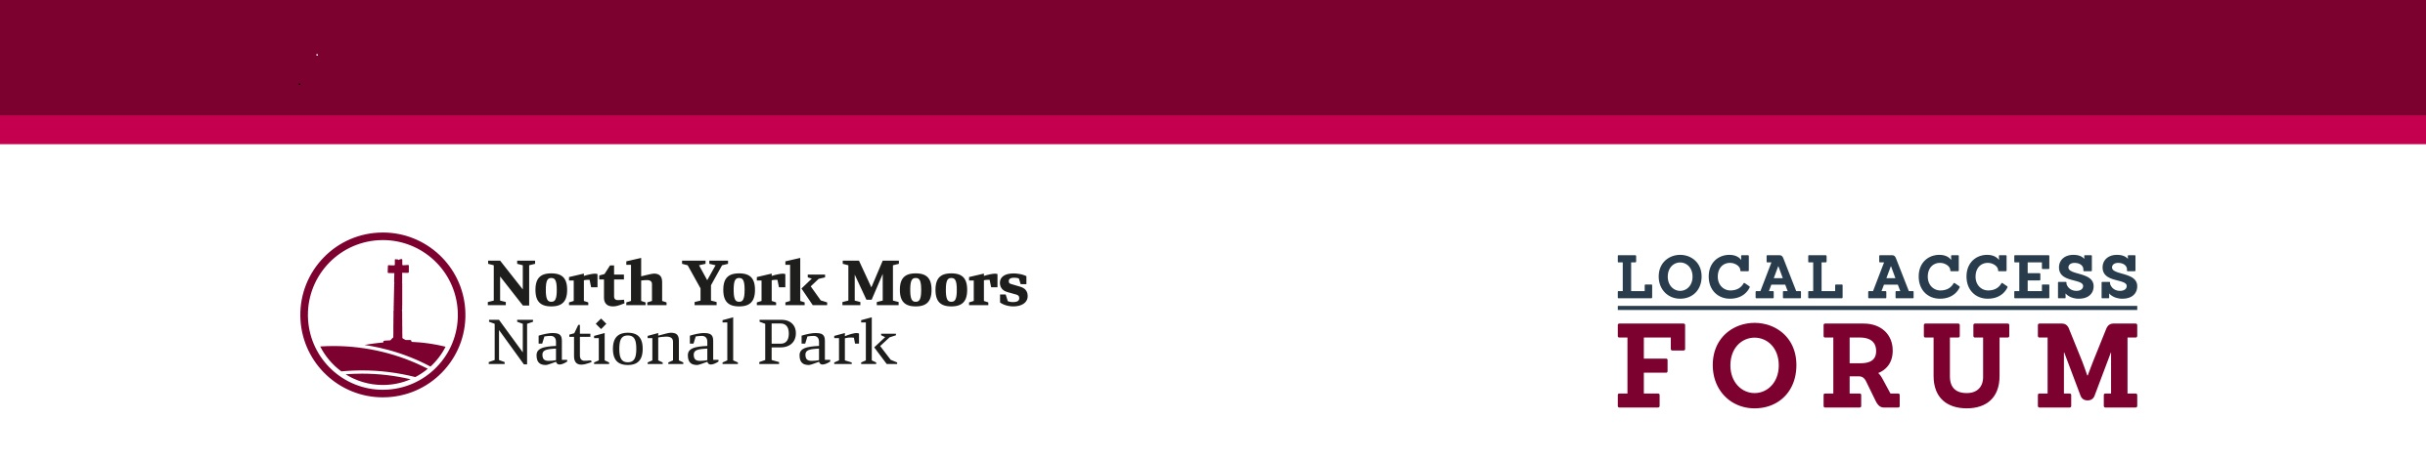
Local Access Forum – General Information
The primary purpose of the Forum is to provide an opportunity for representatives of recreational users, landowners and other interests to advise the National Park Authority on the improvement of public access to land in the National Park for the purpose of open-air recreation and the enjoyment. This should be done in ways that address social, economic and environmental interests, whilst encouraging and assisting access provision. The advice given by the Forum should be of particular local relevance. Agenda items are generally not case specific but could cover issues such as proposals for the definition or management of access land, the imposition of bylaws, long term closure of land, as well as on wider issues considered, for example, in rights of way improvement plans. Regulations prescribe the arrangements for membership, but in broad terms Local Access Forums must have balanced representation of users of access land and rights of way, landowners and occupiers, and other interests especially relevant to the area (see Table 1).
The area represented by the Forum is the whole of the North York Moors National Park, including land in both North Yorkshire and Redcar and Cleveland. Forums have also been established to cover the remainder of Redcar and Cleveland, the Yorkshire Dales National Park and the remainder of North Yorkshire outside national park boundaries.
Further details of the work of the North York Moors LAF including agendas and member names can be found on the National Park Authority’s website: https://www.northyorkmoors.org.uk/about-us/rights-of-way/local-access-forum

Membership of the North York Moors Local Access Forum

The National Park Authority adopted the following principles regarding the Local Access Forum:
- The Chair will be appointed from the membership at the AGM.
- Membership will comprise a maximum of 17 members plus Officers and LAF Secretary
- Members must bring a wide range of experience including:
a) RoW/recreational use: walking, horse-riding, cycling, climbing, carriage driving, motor sport
b) Land management: moorland owner/agent/commoner, farm owner/agent/tenant, forestry, game keeping, nature conservation
c) Other interests: heritage, tourism, health, local business, education, transport, and local communities, see table 1.
- Three Forum members will represent other Authorities: The National Park Authority, North Yorkshire Council and Redcar and Cleveland Borough Council.
- The term of appointment is three years.
- The Forum should contain, wherever possible, equal numbers of members ascribed to each of the groups shown in the categories above. Members who have experience in more than one of the categories will be particularly useful.
- Members other than those nominated by NYMNPA, NYC and Redcar & Cleveland BC, will be appointed to the Forum by the National Park Authority via an application process.

Table 1
Member Categories | Number of members
RoW/REC - Recreational use, e.g. walking, horse-riding, cycling, climbing, carriage driving, motor sport | 4 (+2 vacancies)
LAND - Land management, e.g. moorland owner/agent/commoner, farm owner/agent/tenant, forestry, game keeping, nature conservation | 4
OTHER - Other interests, e.g. heritage, tourism, health, local business, education, transport, and local communities | 3 (+1 vacancy)
North York Moors National Park Authority member | 1
North Yorkshire Council member | 1
Redcar and Cleveland Unitary Council member | 1
Total | 17

Application for Member appointment

Personal details
Surname
Forenames
Title
Address
Home telephone number
Work telephone number
Mobile telephone number
Email address

Position applied for: Member of North York Moors Local Access Forum - 3 year term
Are there any reasonable adjustments you need to help you do the vacancy you are applying for? | Yes/No (if necessary, please give details on a separate sheet)

Evidence of your suitability for appointment as a LAF Member
Please refer to the information included below on Page 4, Local Access Forum General Information
Please outline any relevant professional/voluntary/personal experience which is relevant to being a member of the Local Access Forum?

Why do you want to become a Member of the North York Moors Local Access Forum?

Membership of Local Access Forum
The Local Access Forum needs a balance of interests. Please indicate which interest you wish to represent.
Recreational use (eg, walking, horse riding, cycling, climbing, motor sport - 2 vacancies
Land management (eg, moorland owner/agent/commoner, farm owner/agent/tenant, forestry, gamekeeping, nature conservation. | n/a for this application
Other interests (eg, heritage, tourism, health, local business, education and local communities). 1 vacancy

Declarations
Have you ever been convicted of a criminal offence? yes/no
If yes, and the offence is not considered to be spent under the Rehabilitation of Offenders Act 1974, please give details on a separate sheet.
I declare that all information given in support of my application is, to the best of my knowledge correct.

Signature; …………………………………………………….

Date: …………………………………………………………….

Notes
Please email completed application forms to Judith Seaton, Executive Support Team Leader, at J.Seaton@northyorkmoors.org.uk
Alternatively, you can post them for the attention of Judith Seaton, to
North York Moors National Park Authority
The Old Vicarage
Bondgate
Helmsley
YO62 5BP

The North York Moors National Park Authority is registered under the General Data Protection Regulation (GDPR) and the Data Protection Act 2018 (DPA) and information on your application form will be used for our recruitment purposes only. Application forms for unsuccessful applicants will be held for no longer than 12 months and then destroyed.

Key Dates:
Deadline for applications: Friday, 8 May (midday)
Shortlisting: Wednesday, 13 May 2026 (end of day)
Virtual interviews on Teams: Friday, 15 May 2026 times to be confirmed to shortlisted candidates.

Next Local Access Forum meeting on Tuesday, 3 June 2026 at 10.00

