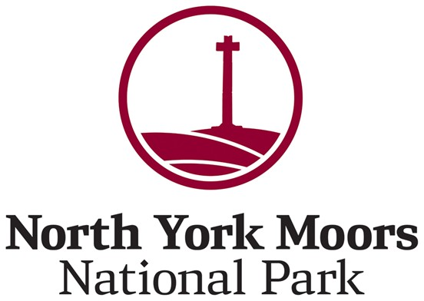
Call for Sites

Site Submission Form
Please use this form to tell us about land or buildings you would like us to consider as part of future planning work. Submitting a site does not mean it will be allocated or granted planning permission.
Please complete one form per site.
Section 1. Your Details
Your name and address:
Email:
Telephone number:
Site Visit (if required). Please let us know if a site visit needs to be arranged in advance.
Contact details for site access (if different from above):

Section 2. Site Details
Site address or location:
Parish:
Landowner status:
Sole owner / Joint or Shared Ownership / Don’t own site
What best describes the site? (delete as appropriate or add text)
- Open land / field
- Garden or paddock
- Previously developed land (brownfield)
- Existing buildings on the site
- Empty or underused buildings
- Unsightly land or eyesore in the landscape
What is the current use of the site? (e.g. agriculture, storage, residential, vacant)
(free text)
Are you aware of any issues that might affect development? Please delete as appropriate (no technical detail needed):
- Access or highway constraints
- Flooding or drainage issues
- Landscape or visual impact
- Wildlife or trees
- Heritage impact (listed building, conservation area, archaeology)
- Ownership or legal issues
- None known
- Other: (please explain)
(free text)

Section 3. Proposed Uses and Availability
What use are you proposing for the land?
- New homes
- Affordable homes
- Self or custom build
- Business or employment uses
If housing, approximately how many homes can the site support? (Your best estimate is fine)
(free text)
When do you think the site could realistically be available?
- Now
- Within 1 – 5 years
- Within 6 – 10 years
- Longer term or uncertain
Why do you think this site is suitable? Please briefly explain why you think the site should be considered (e.g. location, availability, use of buildings, local need).
(free text)

Section 4. Declaration and GDPR
By submitting this information, I confirm that the information provided is correct to the best of my knowledge.
By submitting this information, I agree to my data being used in accordance with GDPR.
The North York Moors National Park Authority must comply with the General Data Protection Regulations (GDPR). This means that the Authority has a duty of care towards the personal data that it collects and uses. When collecting personal information from you, we will tell you how this information is to be used and will not use your details for other purposes without your consent. The data collected will only be used for the purpose of informing the Authority of views on the draft planning policy documents. The Authority's Data Protection Officer role is managed by Veritau - www.veritau.co.uk
What happens next?
All submitted sites will be assessed as part of the plan‑making evidence base.
All submitted sites will be published, but personal contact details will not be made public.
Submitting a site does not guarantee it will be allocated or receive planning permission.

