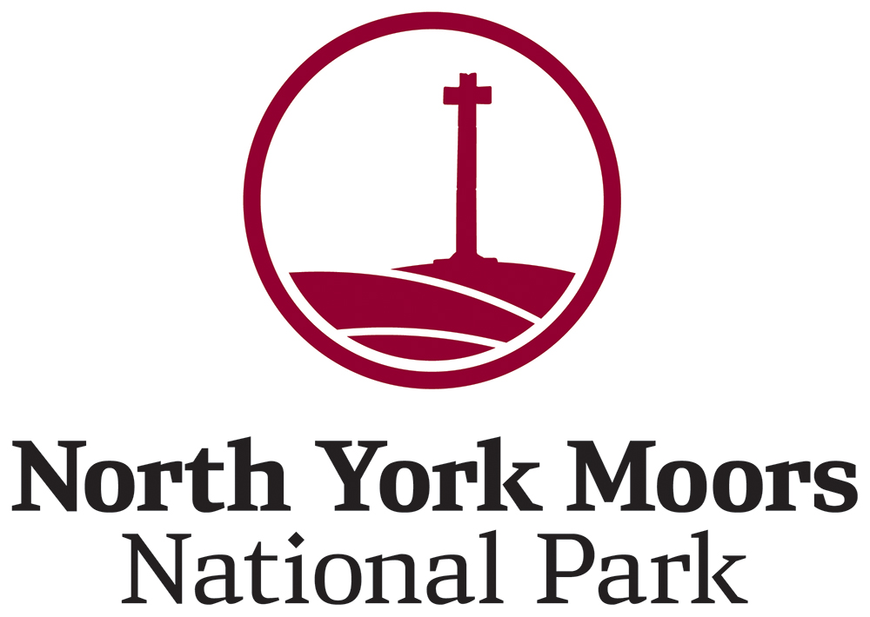

Job description
Post of Young Volunteer Assistant
Post number - RW330
Grade B - 100 hours maximum fixed term contract from 1 Aug 2025 to 31 March 2026 (with possible extension to September 2026 subject to funding)
Recreation & Wellbeing Department
Responsible to Future Generations Wellbeing Manager
Work base - Danby Lodge National Park Centre/Home based

Purpose
To engage young people from the National Park and surrounding areas through volunteering. Inspiring them to understand, experience and treasure the North York Moors and be actively involved in its future.

Main duties and responsibilities
1. Assist with a programme of youth volunteers.
2. Assist in the delivery of an established range of creative and innovative activities, working with and motivating a team of volunteers.
3. Integrate appropriate accreditation schemes into the above programme (such as the John Muir Award).
4. Assist in the monitoring, recording and evaluating of the outcomes from the above programme.
5. Take responsibility for ensuring that the health and safety of all people participating in the above programme is effectively managed. This will include following the Authority’s established Health and Safety and Safeguarding policies.
6. Ensure that all work is carried out in accordance with the Authority’s Values and Equalities policies.
7. Undertaking any other duties which the Future Generations Wellbeing Manager/Family Engagement Co-ordinator may reasonably request.

Person specification
Qualifications | Essential | Desirable
Qualification relevant to working with young people, BEd, PGCE, Youth Work | - | Yes
First Aid Certificate | - | Yes

Experience and knowledge | Essential | Desirable
Previous experience of working with young people, particularly using the outdoors as a catalyst for exploration | - | Yes
Previous experience and understanding of working with young people from less advantaged areas | - | Yes
Previous experience of establishing, organising and delivering programmes of youth volunteering | - | Yes
An understanding of, and an enthusiasm for, the day to day application of child protection and health & safety policies & practices | Yes | -
Experience of delivering practical work tasks | - | Yes
Strong ICT ‘user’ skills, including the ability to use e-mail, word processing spreadsheet and database packages effectively | - | Yes

Communication skills | Essential | Desirable
Ability to inspire young people and volunteers about the North York Moors and National Parks | Yes | -
Good interpersonal skills, including ability to build a rapport with a wide range of people | Yes | -

Self-management | Essential | Desirable
Good organisational skills | Yes | -
Able to work as part of a small team of staff and volunteers | Yes | -
Able to work and resolve issues without close day to day supervision | Yes | -

Personal attributes | Essential | Desirable
A real empathy and ‘feel’ for what inspires young people and volunteers, with an ability to demonstrate tact and patience | Yes | -
Flexible attitude to working hours and days (particularly weekend working) | Yes | -
A level of physical fitness appropriate to the post | Yes | -
Full, clean driving licence | Yes | -

Post of Youth Volunteer Assistant

Pay
You will be paid between £13.05 - £13.47 per hour.

Training
Training will be provided in first aid and safeguarding.

Values
Our Values reflect the way in which we all deliver our work and interact with people. The Values are visible in our work, and we hold each other to account for them, celebrate when we demonstrate them, and use them to help us make decisions and consider our priorities.
- Proud: We are proud to be a part of an organisation that conserves, enhances and champions this spectacular landscape – each of our roles makes this possible.
- Professional: We are doers, enablers, inspirers - we uphold the highest professional standards to bring about positive change for the National Park.
- Welcoming: Inclusivity and empathy are at the heart of who we are and what we represent - the National Park is a place for all.
- Collaborative: We work positively and proactively with others to achieve our shared vision of the North York Moors.

Conditions of service
The appointment is based at Danby Lodge National Park Centre, Danby. Delivery hours are 8:30 to 16:30 on weekend days.
The postholder will be eligible to join the Local Government Pension Scheme. Full details of the LGPS, together with information about how to join, will be sent to the successful applicant.
An enhanced DBS with barred list check is required for this post.

Applications
If you wish to apply, you will need to fill in the short application form which includes the following questions:
1. Why are you interested in this role? (Maximum of 50 words)
2. Through your interest and/or experience, why do you think opportunities for caring for our National Parks are important for young people to access? (Maximum of 200 words)
3. Please tell us about your experience of working with young people. (Maximum of 200 words)

Selection and interviews
Applications must be completed by midnight 20 August and emailed to recruitment@northyorkmoors.org.uk
Online interviews are to be held on the evening of 27 August.



