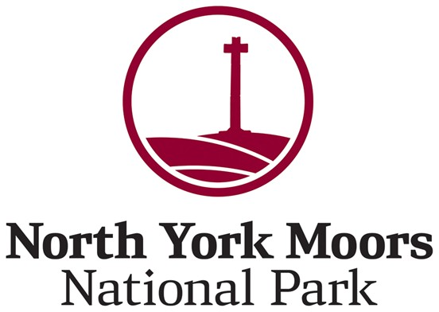
Local Plan – Current Thinking

Data Protection Statement
North York Moors National Park Authority must comply with the General Data Protection Regulations (GDPR). This means that the Authority has a duty of care towards the personal data that it collects and uses. When collecting personal information from you, we will tell you how this information is to be used and will not use your details for other purposes without your consent. The data collected will only be used for the purpose of informing the Authority of views on the draft planning policy documents. The Authority's Data Protection Officer role is managed by Veritau - www.veritau.co.uk
Please indicate that you consent for your information to be held: Yes / No

Your details
Your name:
Organisation (if applicable)
Your email:
Your address:

Conversation 1 – Nature recovery and climate action at a landscape scale

How do you think the Local Plan can be improved to meet the challenges of climate change?
Enter answer here

How can planning policies better enhance nature and biodiversity?

Conversation 2 – Recreation, health and wellbeing

Where do you think recreational development in the National Park should be located and do you think the current levels are at the right scale? Do you have any views on the type of recreational and tourism infrastructure that is needed or is appropriate?
Enter answer here

Does there need to be more flexibility to allow low impact recreational uses in isolated or remoter farm buildings?
Enter answer here

Conversation 3 – How do we decide which villages are appropriate for new development?

Do you think the current hierarchy works well? Should other villages be included? What changes would you like to see?
Enter answer here

Should some villages close to larger urban settlements outside the National Park be designated as Larger Villages, reflecting their sustainable location and access to services?

Conversation 4 – Housing, including overall numbers, locations and tenure

As long as policies fully support landscape protection do you agree that we need to build more homes in the National Park to help meet the needs of local communities?
Enter answer here

Should all new homes be required to be lived in as a main home and be subject to a principal residence condition across the whole National Park (removing the current location connection requirements in Smaller Villages?)
Enter answer here

What are your thoughts about identifying housing sites on the edges of villages?
Enter answer here

Do you have any views on whether we should look to find land for an exemplar project that can demonstrate how best to build green or ‘eco’ homes, or how we can best encourage self-build housing?
Enter answer here

Is there anything else that you would like to let us know about, or do you have any comments about our current plan?
Enter answer here

