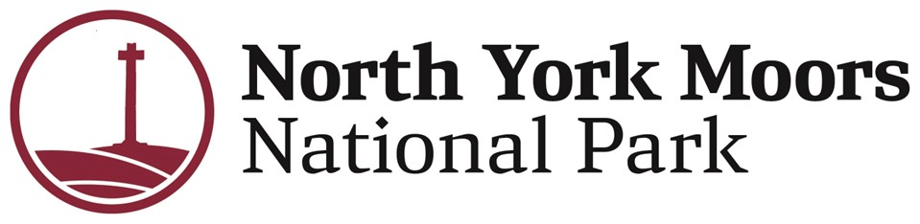
Co-opted Young Member Opportunity

Recreation & Wellbeing Forum

Your Voice. Your National Park. Your Impact.
Are you 18–30 and care about nature, wellbeing, and people? Want a real say in how one of the UK’s most iconic landscapes is shaped for the future? Want to be paid for your time and valued contributions?
National Parks have been in existence for over 75 years. We have a statutory duty to conserve the landscape, wildlife and heritage whilst also ensuring people of all ages can enjoy the benefits of accessing these special places.
We’re looking for a young person to join the National Park Authority as a Co-opted Member with a focus on our Recreation and Wellbeing work - bringing fresh ideas, lived experience, and youth perspectives straight into decision-making at the heart of the National Park.
You’ll also get the chance to observe senior decision-making across the organisation, including meetings of the National Park Authority (NPA) and the Finance, Risk, Audit and Standards Committee (FRASC).
This is a rare opportunity to make a real impact, build confidence, and gain experience in environmental leadership, public decision-making, and community engagement—all while helping shape the future of the North York Moors.

About the Recreation & Wellbeing Forum

What the Forum Does
- Meets quarterly to guide recreation and wellbeing work
- Supports the Authority’s Strategy, Business Plan, and Management Plan
- Helps develop policies and ideas around access, recreation, and wellbeing
- Feeds recommendations directly to the Full Authority

About the Role

Why This Role Exists
We want young people’s voices in the room, not as an afterthought. This role is all about making sure the Park works for younger generations, diverse communities, and future users.

What You’ll Be Doing
As a Co-opted Member, you’ll:
- Take part in Recreation & Wellbeing Forum meetings
- Observe NPA and FRASC meetings to see how decisions are made
- Share ideas on how the Park can better support young people and wellbeing
- Help shape inclusive access to nature
- Act as a link between the Authority and youth audiences

Time Commitment
Around 2 days per month, including:
- 3–4 Forum meetings per year
- Optional attendance at NPA and FRASC meetings
- Occasional training days, development sessions, or events
Meetings may be online or in person, with travel support provided.

Who We’re Looking For
You might be a student, early-career professional, creative, volunteer, or community organiser. What matters most is your perspective.
You’ll need to be:
- Aged 18–30
- Interested in nature, wellbeing, communities, or access
- Curious about public service or environmental issues
- Keen to speak up and share ideas
No formal experience required—just enthusiasm, openness, and a willingness to contribute.

What You’ll Gain
- £700 annual allowance, paid monthly
- Travel and subsistence expenses covered
- Mentoring and support from Park staff and Members
- Access to training, networking, and development opportunities
- A standout addition to your CV
- A genuine chance to influence real-world decisions
- A meaningful role in shaping the future of the North York Moors

Why This Matters
National Parks should feel welcoming, relevant, and inspiring for everyone—not just now, but for generations to come.
By joining us, you’ll help ensure young people’s voices shape the future of our landscapes, communities, and wellbeing.

How to Apply
Send us a short expression of interest by 10 July 2026. You can choose:
- A video (up to 3 minutes), or
- A written statement (up to 2 pages)

Please include:
- Your contact details
- Why you’re interested in the role
- What you’d bring to the Forum
- Any relevant experience (voluntary, community, creative, or lived experience)
- A time you made a positive impact in a group or community
Email your application to: Judith Seaton – j.seaton@northyorkmoors.org.uk

