

Conservation Area Character Appraisal and Management Plan

  - Appleton-le-Moors

  - 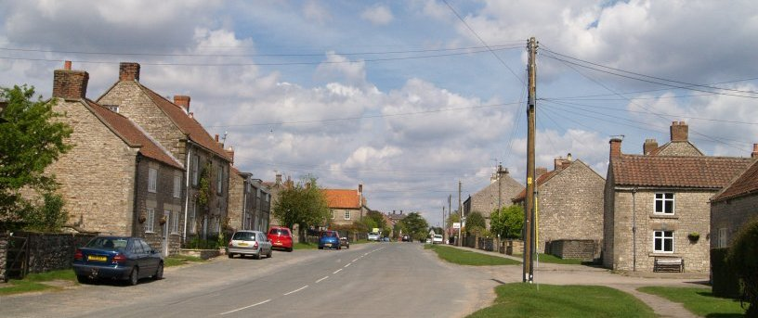

  - January 2025

1.0 Contents
1.0 Contents 2
2.0 Summary of Significance 4
3.0 Introduction 5
4.0 Location and Context 7
Geographical landscape 7
5.0 The History of Appleton-le-Moor 8
6.0 General Character and Settlement Form 10
6.1 Main Street 10
6.2 Site Layout 11
6.3 Surface Treatments, Boundaries, Open and Green Spaces 11
6.5 Considerable Significance 13
6.6 Opportunities to conserve and enhance 13
7.0 Archaeology 13
7.1 Some significance 14
7.2 Unknown significance 14
7.3 Opportunities to conserve and enhance 14
8.0 Vistas and Views 15
8.1 Then and now 15
8.2 Considerable significance 16
8.3 Opportunities to conserve and enhance 16
9.0 The Historic Buildings of Appleton-le-Moors 18
9.1 Doors 20
9.2 Windows 22
9.3 Shop Fronts 23
9.4 Boundary Treatments 24
Pavements and verges 25
9.8 Considerable significance 26
9.9 Some significance 26
9.10 Opportunities to conserve and enhance 26
10.0 Recommendations for Future Management 26
10.1 Conserving and Enhancing the Street Plan, the Surfaces, Open Spaces and Boundaries of the Conservation Area 26
10.2 Conserving and Enhancing the Archaeology of the Conservation Area 27
10.3 Conserving and enhancing the Historic Buildings of the Conservation Area 27
10.4 Conserving and enhancing the little architectural and historic details 28
10.5 Recommended boundary changes 28
11.0 Conclusion 28
12.0 Appendix and Acknowledgements 30
13.0 Management Overview 31

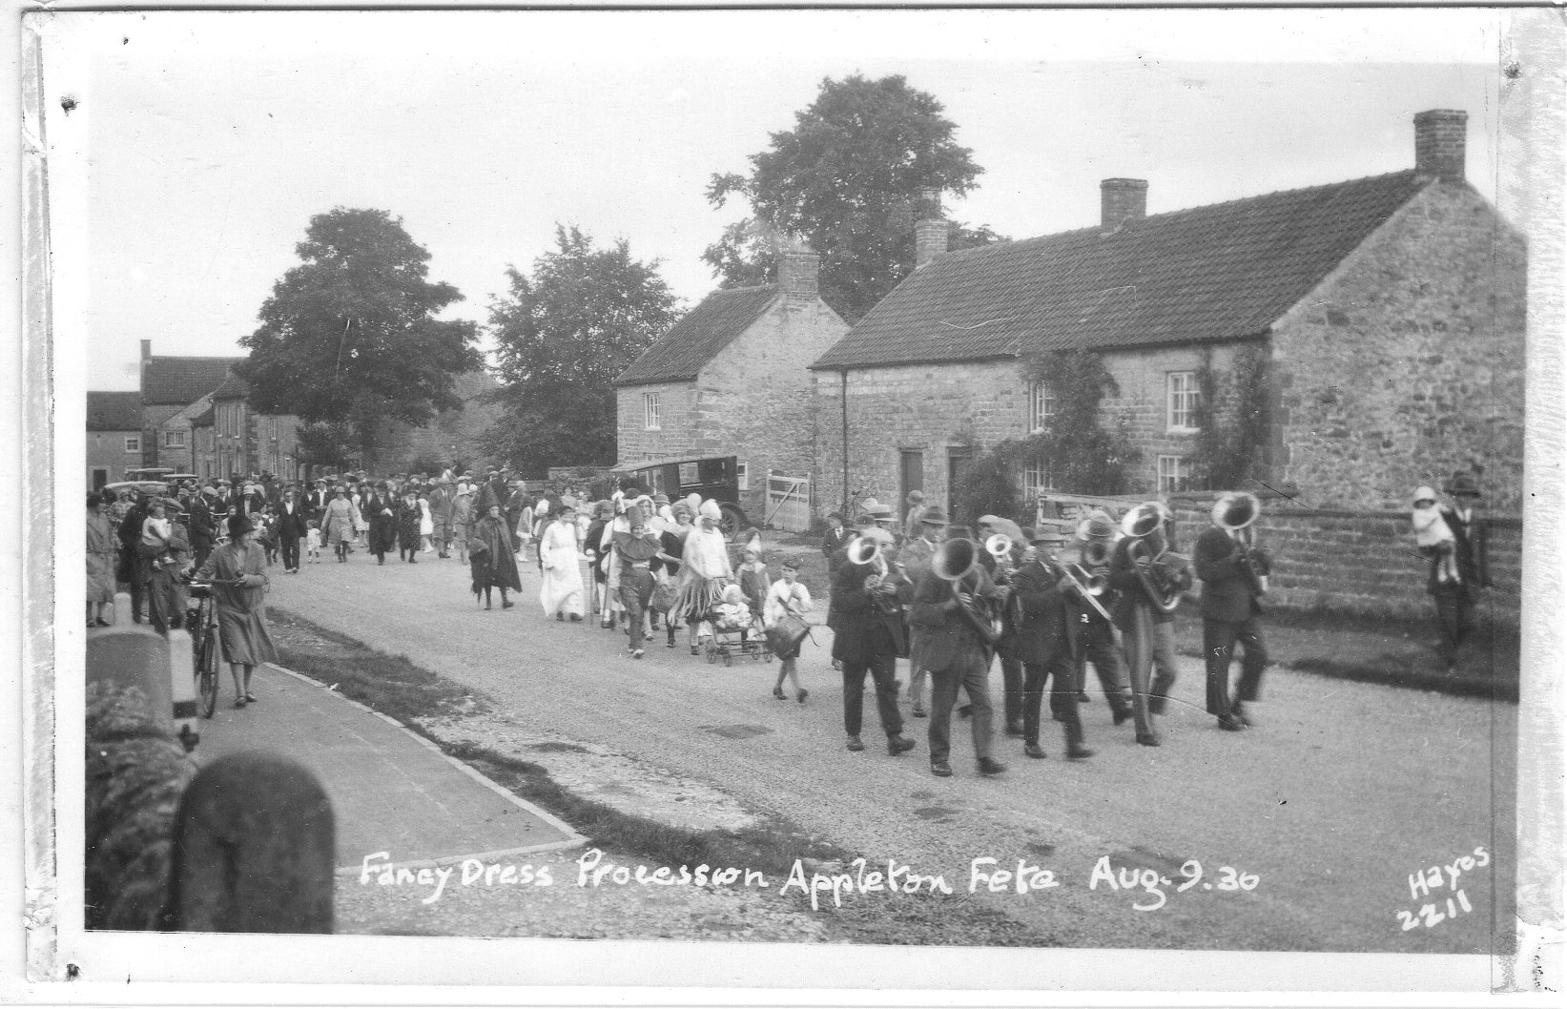

2.0 Summary of significance
The special character of Appleton Le Moors lies in its 12th century layout and its position on the edge of the moor. The village follows a strong linear pattern with long burgage plots, many with surviving agricultural outbuildings to the rear. Houses are tightly packed, with very few glimpses of the surrounding moorland from within the core of the village. The character of the village is distinctively agricultural, farms sit among the stone cottages of the street-scene with some barns still in agricultural usage.
Properties are back of pavement or behind small gardens to the front, set behind low stone walls, some topped with iron railings. Architectural ornamentation on buildings is scarce. That said Appleton Hall at the end of the village (built in the 1850s for Joseph Shepherd) has a strong Italianate form. Burlingham House also has a distinctive grand stone portico, believed to have come from the Hall when it was being renovated for Joseph Shepherd. Boundary features are low stone walls with a high proportion of surviving early 20th Century wrought iron railings.
Considerable significance
- Closely packed core
- 12th Century layout with long burgage plots to rear
- Distinctive agricultural character with many farms and barns
- Strong linear layout
- Stone houses with little architectural ornamentation
- Few open spaces in-between properties, small gardens to the front
- Low stone boundary walls, good proportion of historic iron railings
- Strong retention of historic windows and doors
- Strong dominance of Appleton Hall and its Italianate form.
- Grade 1 listed Christ Church by J L Pearson and its Early Gothic style
- The Appleton Reading Room built in 1911 stands proud at the beginning of the village (although outside the Conservation Area)
- Building materials are stone with a red pantile roof. Few slate roofed buildings, nearly all attributed to Joseph and Mary Shepherds conversion/re-building of the village municipal buildings.
- The sparce nature of Appleton Common (at the beginning of the village)
- Long distance views over to the Vale of Pickering and surrounding farmland from the corner of Manor Farmhouse.

3.0 Introduction
Located within the North York Moors National Park, the Conservation Area of Appleton-le-Moors was designated in December of 1977. There are over 9,800 Conservation Areas in England of which 42 are in the North York Moors National Park. These places are protected under the provision of section 69 of the Planning (Listed Buildings and Conservation Areas) Act 1990 which defines them as areas ‘of special architectural or historic interest, the character and appearance of which it is desirable to preserve or enhance’.
Conservation Areas give broader protection than listing individual buildings as features of historic, architectural and landscape interest are recognised as part of its character. Conservation Area designation introduces manages the way owners can alter or develop their properties, so the special interest of the Conservation Area is not devalued. Owners of residential properties often consider these controls to be beneficial because they also sustain and enhance the attractiveness and value of property within it. These controls include:
- The requirement in legislation and national and local planning policies for new development to preserve and enhance special character;
- Removal of certain Permitted Development rights
- Control over demolition of unlisted buildings
- Control over works to trees
- Control over advertisements
- Restriction on the types of development which can be carried out without the need for planning permission (permitted development rights)
This report assesses those features and qualities, which give Appleton-le-Moors its unique special interest and which justify its designation. It seeks to identify the character defining elements of the Conservation Area and describes the degree of significance that can be attached to those elements such as the street plan, open spaces, vistas and views and the historic buildings. It then goes on to make recommendations on how to conserve and enhance those elements of significance and makes further recommendations to guide future management decisions and development proposals.
No appraisal can ever be entirely comprehensive and the omission of any particular building, feature or space in the village, should not imply that it is of no interest.

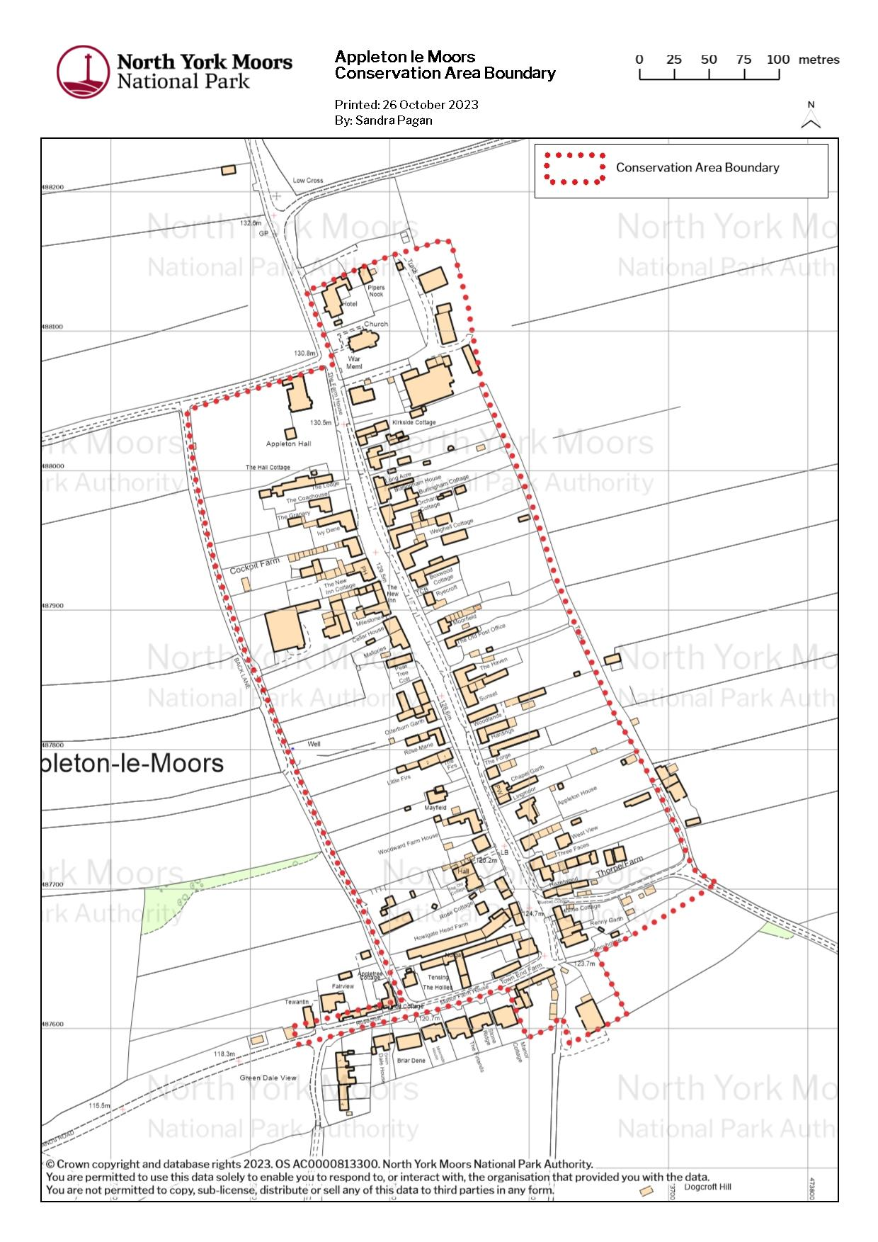 Figure 1: The Conservation Area of Appleton-le-Moors, the boundary is shown with the dashed red line

4.0 Location and context
One of forty-two Conservation Areas within the North York Moors National Park, Appleton-le-Moors is positioned amongst an expansive landscape composed of distinctive purple heather tones and rural scenery. Appleton-le-Moors is a rural village located approximately 34.2 miles northeast of York, 13.6 miles northwest from the market town of Malton and 9.1 miles northeast of the market town of Helmsley, on an elevated slope.
Described as one of twenty-nine villages present within the Pickering District, Appleton-le-Moors is one of eighteen that merit the term planned. The village resonates a mix of traditional vernacular buildings from as early as the Medieval Period. The village itself, unspoilt in nature attracts ramblers, cyclists and naturalists from far and wide.
Identified as one of the most strikingly villages within the region the Conservation Area of Appleton-le-Moors covers an area of 11.44 hectares and contains around 60 buildings with a high number of auxiliary outbuildings. The 2011 census population of Appleton-le-Moors was recorded at one hundred and sixty-four and has witnessed a gradual decline in recent years.

Geographical landscape
Set within the North York Moors National Park, Appleton-le-Moors is located 400ft above sea level at a slight gradient running east to west. The village is geographically positioned west of the River Seven, overlooking the Vale of Pickering and Sinnington. Set amongst the North Yorkshire Corallian limestone hills, the landscape boasts lime rich soil, desirable for cultivation and agriculture use. A mix of arable and pastureland is subdivided into toft and crofts laid in regular strips. This expansive land is juxtaposed by dense woodlands and what would have been historic apple orchards from the Abbey.
Located east of Spaunton quarry, Appleton-le-Moors depicts evidence of historic lime production with the presence of lime kilns in the area. Historic Environment Records date the kilns, located south of the village (east of Dogcroft hill), to the 19th century. Lime produced is likely to have been used as a nutrient in the agricultural industry or as an aggregate for building.

5.0 The history of Appleton-le-Moors
The origins of Appleton-le-Moors reside within its 12th Century planned linear formation. The earliest surviving evidence of a settlement within this area is demonstrated through the presence of ‘Tumuli/barrows’. The Tumuli can be found in Low Common, around the junction of Headlands Road and the A170, surrounding Whinny Hill Farm.
At least seven Bronze Age round barrows have been found, some of which are designated as Scheduled Ancient Monuments. Suggestions of an ancient ceremonial/ritual site would imply an associated settlement nearby or within the village of Appleton-le-Moors. Previous Archaeological finds include the remains of a Romano-British stone cist burial (found 1893), a lithic scatter (found 1957) and a ceramic charm, which were all located near the northwest boundary of Appleton-le-Moors and Spaunton. These finds suggest a well-developed Settlement, possibly Roman or at one point Saxon. Within the Conservation Area itself, a 3rd century Roman coin and pottery shards were unearthed at the site of Long Acre.
Land within the Conservation Area of Appleton-le-Moors was under the ownership of the Manor of Spaunton. At the time of the Domesday survey of 1086, Spaunton Manor was said to be considerable in size, with Appleton-le-Moors being mentioned (however only in summary). Post conquest, Appleton-le-Moors was given by the king to the Abbot of St Mary. In the 12th century, Appleton-le-Moors underwent a process of reorganization as part of the Abbey Estate. Sometime after Domesday, under the order of St Mary’s Abbey, Baschebi (known as a lost village) merged with Appleton-le-Moors (late C13), in a grand scheme of reorganisation across the Manor. In the amalgamation process, Appleton-le-Moors acquired a north field. Developing a three-field system (east to west), effectively increasing it in size and its potential crop yield.
This planned form of Appleton-le-Moors laid out the village in tofts and crofts, east to west of Headlands Road. Eastern and western garths around c.330ft long were created, and filtered onto Back Lanes, forming the distinguishable linear pattern of the village seen today. Map regression dictates that western plots, which are slightly bigger, were deemed more advantageous due to the gentle slope of the land and water systems available. Other suggestions of medieval settlement include the Chapel of St Mary Magdalene and a medieval oven. The C12 chapel is thought to be located at the southern end of the village, now Manor Farmhouse and Manor Cottage. Described in the Historic Environment Records as a free chapel, the chapel was independent of the Parish of Lastingham with its last known record published in 1616. The 13th-15th century three phase medieval oven with a pitched stone floor in its final phase is believed to be located west of the chapel, now known as The Firlands. The Manor was sold off following the dissolution of the monasteries in the 1530s. New landowners subsequently became freeholders, inheriting ancient rights in the Commons. Sir John Bulmer of Riseborough sold the Manor to Lord Grey de Wilton whose successors sold off parts of the estate.
In the 19th century Joseph Shepherd, a native of the village and wealthy shipowner/merchant returned to Appleton-le-Moors to see out his retirement years. In 1854 Shepherd built his home, a substantial Victorian villa located to the north of the village. Passing away unexpectedly, as an act of memorial, Mary Shepherd, Joseph’s widow, oversaw the building and completion of Christ Church (1863-5) and the School (1867), now the Village Hall and the Vicarage (1963). Commissioning the Victorian Gothic architect John Loughborough Pearson (1817-1897). The School, closing in 1969 was entrusted to the village to serve as a Village Hall. Since then, the hall has undergone major refurbishment (1999) with the aid of grant schemes enabling the production of multifunctional spaces for community and social events.
Other noteworthy aspects of the village include that of Appleton Mill. A Grade II Listed Building located east of the village, accessed through Hamley Wood, bounding the River Seven. Thought to be of medieval origin, with subsequent successive buildings, the current Mill dates from c.1760. The production of corn would have acted as an economic generator for the village. Thought to have ceased production in the 1940s the mill now serves as a farm and farmhouse, with some milling machinery still present.
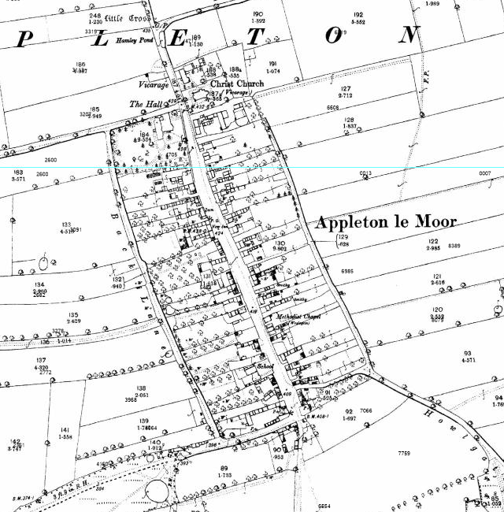

Figure 2: The OS map 1893. The long burgage plots can be clearly seen along with its linear layout.
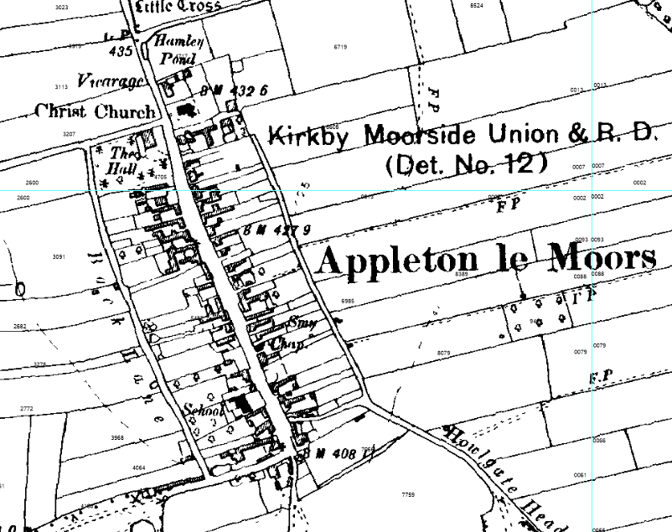
Figure 3. The OS map 1914 showing little change.

6.0 General character and settlement form
Throughout the centuries, Appleton-le-Moors has had a variety of names spanning many charters: Apeltun, Wodeapleton, Dweldapleton, Woodappleton, Appleton in the Moors and the more recent Appleton-le-Moors. The ‘le’ is believed to have been added by the Post Office.
One principal road acts as a thoroughfare through the village reinforcing its linear settlement form. Headlands Road, from the A170, winds through Appleton Common, directly through the village, terminating at Kirkgate Lane. Post war development south west of the Conservation Area extends the settlement westwards, however, the majority of which is outside of the Conservation Area boundary. Back lane starting at The Hollies and ending at Appleton Hall, loops its way around the back of the properties to the West of the Main street and marks the boundary line of the Conservation Area,

6.1 Main Street
The Main Street (Headlands Road) runs through the Conservation Area, orientated north to south. This creates a linear street pattern of primary elevations and an interlacing of gable ends fronting the highway. With at least 70% percent of the buildings fronting directly onto the highway, most of the original buildings would have done so. Positioned within their toft tight to their north boundary, southern access points allow vehicular and agricultural entries to Garth's. However, over the trajectory of time this process has been gradually eroded through recessed and centralised property within tofts.
Buildings of the 18th and 19th century make up the historic core of the village. Success and development are owed to that of the farming and weaving industries. Architectural development was supported by the extension and adaptation of medieval longhouses, farmhouses and workers cottages. Development of the mid to late 20th century eroded the linear settlement, expanding the entry avenue to the village. Within this time period features such as the pond, Pinfold Cottage and the Poorhouse were removed in favour of modern development.

6.2 Site Layout
Throughout the village the site layout generally remains the same as that of the medieval period. Themes can be identified as:
- The majority of buildings face onto Headlands Road, with few bounding the street front with their gable end.
- Strong build line; most historic buildings are dispersed throughout the village still following their medieval building line, fronting the street.
- Development of the 20th century is sympathetic to the historic character in respect to design and material selection.
- Toft and Crofts running east to west.

6.3 Surface Treatments, Boundaries, Open and Green Spaces
A key feature to the Conservation Area is the large grass verges to the front of properties (separating them from the roadside). To the core of the village a small number of buildings are back of pavement. However, predominantly most of the village properties are to the back of large grass verges which runs through the village separated with a small stream. Most properties have a small garden to the front and a small, centralised stone path which leads up to the front door.
Boundary treatments are predominantly dry-stone walls or formal low stone walls topped with cast-iron railings. Rare are handmade brick walls, which can be seen to the front of grander double fronted properties. Gates are typically wooden 5 bar with stone gate posts, there are few iron gates. Where cast iron railings have been retained, they contribute to the character of the Conservation Area and should be maintained appropriately. All boundary treatments used within the village allow a sense of transparency to the gardens and plots behind. Permeability through boundaries enables the appreciation of views and vistas along the span of garths towards back lanes, east and west.
Surface treatments are concrete and tarmac to the road and roadside pathways. Pathways and driveways to the side of properties are either York-stone flags or cream coloured gravel for driveways. Houses are closely packed with the neighbouring property, although the larger farmhouses have small driveways which lead to rear barns and foldyards.
Boundary materials used within the village allow a sense of transparency. Permeability through boundaries enables the appreciation of views and vistas along the span of garths towards back lanes, east and west.
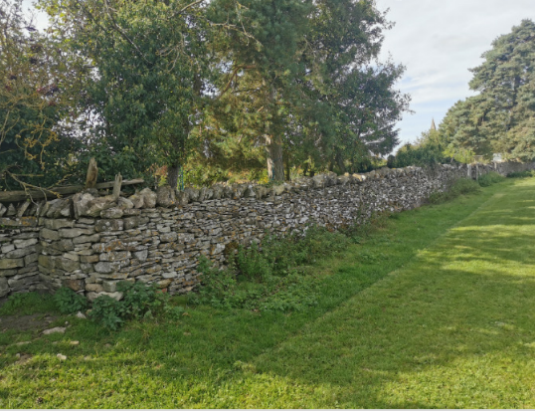

Figure 4: Cock and Hen stone boundary wall.

Boundaries act as a method of security and privacy, keeping the roaming sheep at bay. The use of non-vernacular materials such as machine-made brick and close board timber fencing can upset the historic grain. Some developed boundaries are also too high and overpowering to the character of the area. Boundary treatments within the Back Lanes consist of agricultural post and wire fencing with solid stone boundary walls (cock and hen or rubble finish coping). Throughout the village, public bridleways and footpaths depict public rights of way directly to and from the village by foot, differentiating historic boundaries through public and private access routes.
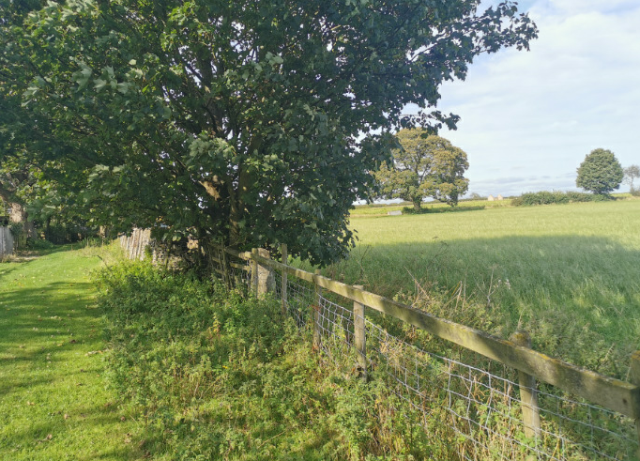

Figure 5: Post and wire fencing

The wider remit of boundaries outside the Conservation Area of Appleton-le-Moors includes the use of dry-stone walls, the River Seven, woodland, overgrown hedgerows and unbounded fields. Historically apple orchards and dense woodland once bound the roads in and out of Appleton-le-Moors.

Pavements and verges
Due to the linear form of the settlement and the proximity to the road, grass verges within the village tend to be considerably wide. Contributing to and enhancing the rural character of the village, grass verges are common land. Separating Headlands Road from the footpath, the grass verges act as a safe buffer zone. This footpath is unassuming and discreet. No kerbing has been used to differentiate the grass verge, with the verge itself acting as the boundary. This contributes to the continuity of the rural character. North of the village, within the Conservation Area boundary and south west of the village in the L winged extension, footpaths with kerbing are found.
A small stream runs through the village adding to the natural aesthetics of the village and adding value to the streetscape. This system provides drainage and is a better alternative as opposed to unsightly manhole coverings and drainage grates. Hard surfacing and concrete slabs have been used to create small ramps over the stream enabling vehicular access to garths. With time grass has grown over and between the hard surfaces, making them blend into the environment.

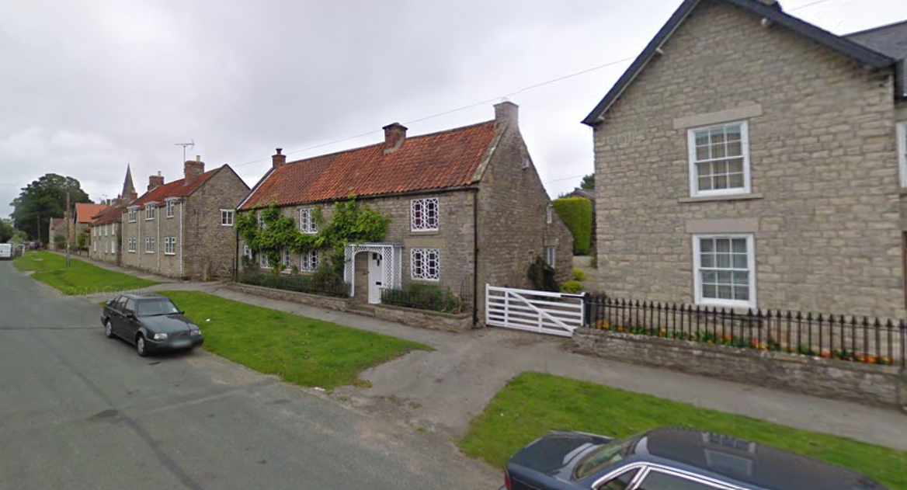
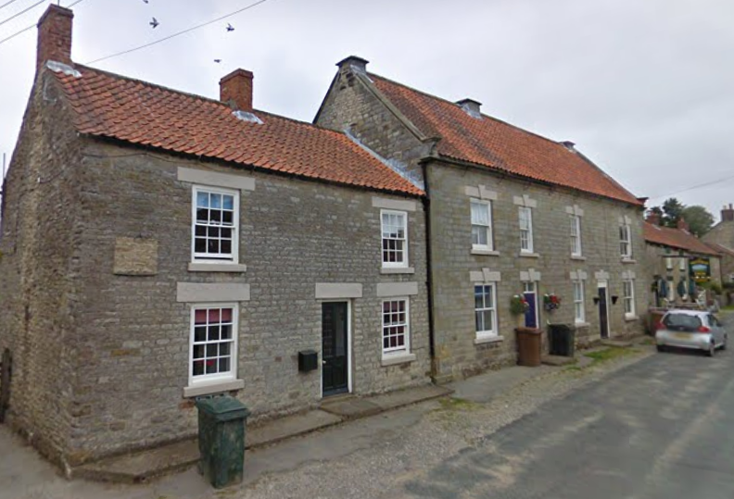
Figure 6 The large grass verge which runs through the village adding
to the amount of green space.
Figure 7: the need for off street parking is seeing the eroding of the grass verges
as cars use them to park on.

6.5 Considerable Significance
- Close relationship of properties in the settlement core.
- Few open spaces to the centre of the village (apart from verges).
- Stone retaining walls with vegetation to soften.
- Visually permeable boundaries to private spaces, especially cast ironwork or low stone walls.
- The harshness of the surrounding moorland and the common land to the start of the village
- Glimpses between properties to rear foldyards and surrounding farmland
- Large grass verges
- Mature trees to larger gardens

6.6 Opportunities to conserve and enhance
- Retain the low level of front boundary walls
- Avoid the removal of historic wrought iron railings
- Avoid the loss of grass verges as they provide much needed greenery to the centre of the village
- Limit the use of tarmac, highways signs and road markings.
- Protect views in-between properties
- Retain the medieval settlement plan
- Hard surfaces such as concrete and tarmac should be limited due to surface water run off

7.0 Archaeology
Evidence of the utilisation and occupation of the landscape during the Mesolithic and Neolithic periods can be seen through several discoveries of worked flints to the northwest and northeast of the village. These include a large assemblage of Mesolithic and Neolithic worked flints, and more scattered finds of flint blades, an arrowhead and an axe head. A neolithic stone axe and other worked flints are also recorded from the southern end of the village. Cropmarks, showing possible prehistoric enclosures to the west of the village, provide further evidence of previous phases of settlement.
Bronze Age burials are present in the wider landscape, identified as either Round Barrows or Round Cairns. The closest to Appleton-le-Moors is recorded as a cropmark to the north of the village, whilst a cluster to the southwest make up a larger Round Barrow cemetery.
During the late 19th Century, a cist burial was uncovered to the north of the village, thought to be either Roman or Saxon in date. Other Roman finds include a ceramic charm in the fields to the north, a Roman coin and pottery found at Long Acre in the 1960s and an Iron Age or Roman quern stone from an unknown location within the conservation area.
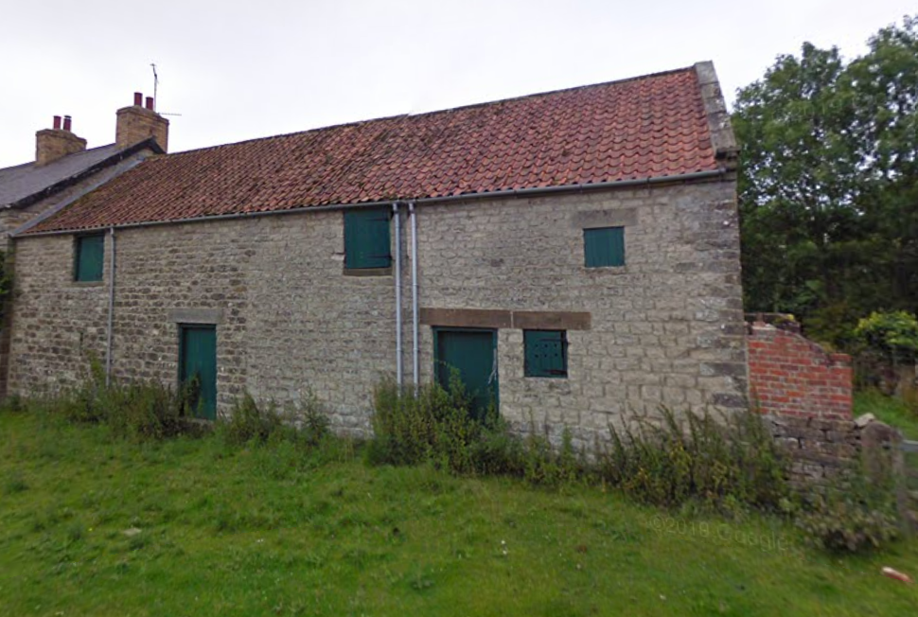
Earthworks south of the village may indicate the location of an early Medieval building and cultivation, potentially predating the 12th Century village site. Other suggestions of medieval settlement include the Chapel of St Mary Magdalene and a medieval oven. The C12 chapel is thought to be located at the southern end of the village, now Manor Farmhouse and Manor Cottage. Described in the Historic Environment Records as a free chapel, the chapel was independent of the Parish of Lastingham with its last known record published in 1616. The 13th-15th century three phase medieval oven with a pitched stone floor in its final phase is believed to be located west of the chapel, now known as The Firlands. Hamley Lane and adjacent hedged boundaries have been suggested to follow the medieval boundary between the village of Baschebi and the fields belonging to Appleton. As the lane is sunken this may have originally been a hollow way on the boundary.

Figures 8: Traditional farm buildings add to the character of the village

7.1 Some significance
- Evidence of blocked openings and former buildings.

7.2 Unknown significance
- Buried archaeology, wells, cess pits and fabric within buildings from earlier dates.

7.3 Opportunities to conserve and enhance
- Proposed alterations to historic buildings should be informed by a Statement of Significance.
- A Heritage Statement may need to consider the impact of new development on sub surface remains.
- Ground disturbance may need to be archaeologically recorded.
- Conserve the boundaries of burgage plots

8.0 Vistas and views
In a nutshell: strong linear pattern, two and one storey buildings, pantiles, channelled views in-between properties to foldyards and distant farmland, barns and outbuildings

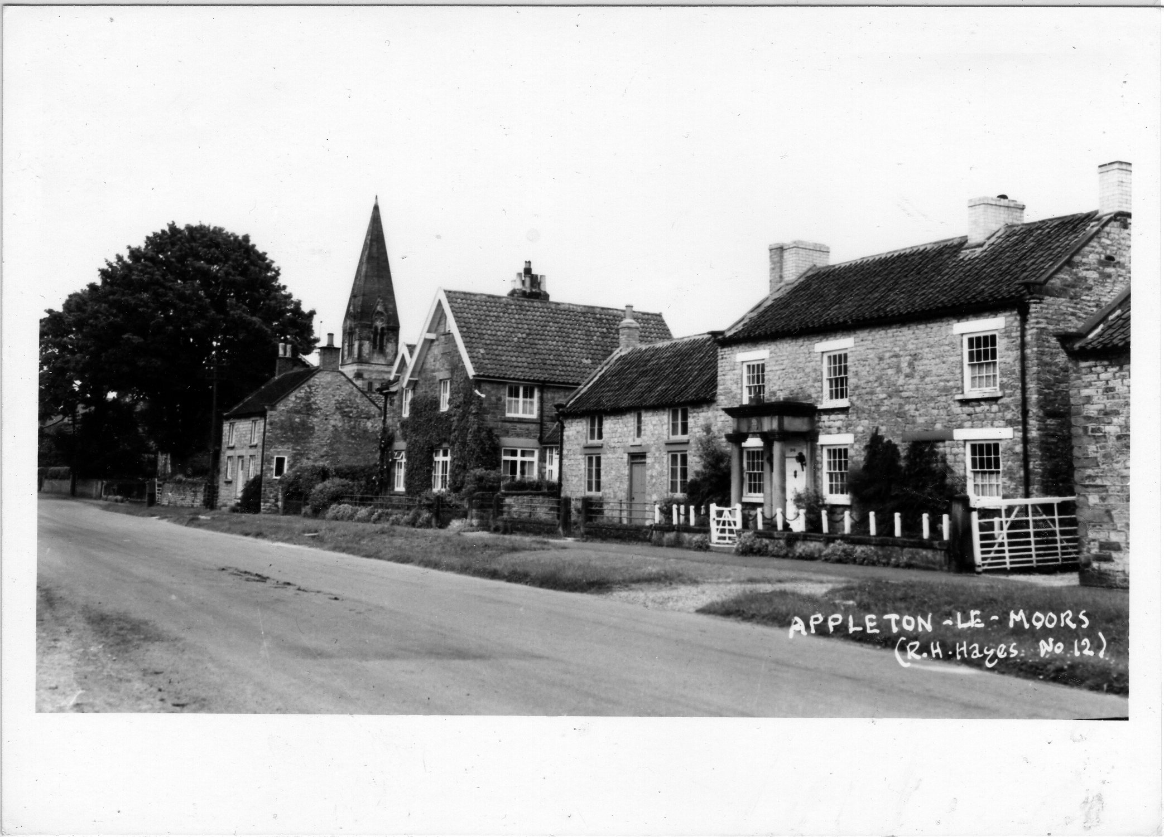
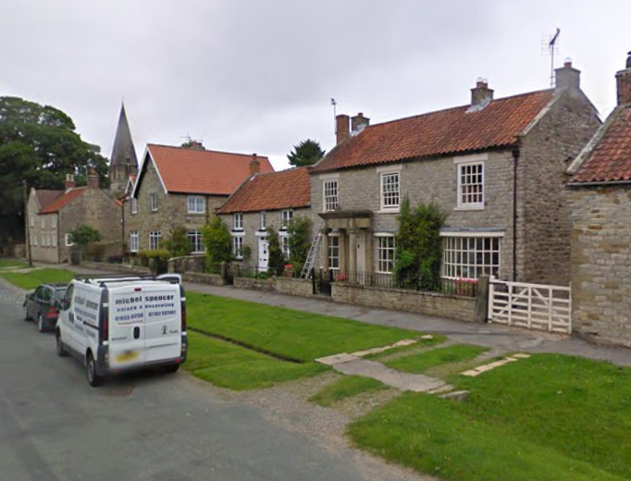
8.1 Then and now
Figures 9: Historic view of Appleton-le-Moors with the spire of Christ Church in the background.
The views and vistas of Appleton-le-Moors are that of a traditional, rural, moorland village. When approaching from the A170 the landscape changes dramatically from a gentle farmland to a more ‘harsh’ open bleak expanse of Common Land as the landscape changes to moorland. Appleton-le-moors is a welcome haven to the bleak environment surrounding. A small, corrugated iron reading room (circa 1920s) stands proud at the start of the village followed by some later 20th century development, with larger gardens and mature trees.
Headlands road which runs through the village suddenly turns 90 degrees and unexpectedly you are in the heart of the village. The strong linear arrangement of buildings creates a channelled view up the Main Street to the top of the village, giving long distance views. Glimpses in-between properties show small foldyards and agricultural buildings to the rear (many still in agricultural use). A key long-distance view is facing south on Headlands Road towards Manor Farmhouse. There is a small public footpath which runs down the length of the farmhouse out towards open farmland and gives spectacular views over the Vale of York. To the top of the village the grand Italianate Appleton Hall dominates the street-scene and many key views being three storeys high and looming over the skyline. To the top of the village is the grade 1 listed Christ Church with its sharp spire, which features in many key views throughout the village. The Church, next to its gothic style Vicarage is a symbol of the Victorian ideal of village life and creates good views across the Conservation Area.

Considerable significance
- The channelled view of the village from the Main Street (Headlands Road)
- Views along garths and back lanes.
- Views to the surrounding farmland/moorland.
- Views of the Church Spire.
- Visually permeable boundaries giving glimpses to gardens and green spaces
- Views of traditional agricultural buildings

8.3 Opportunities to conserve and enhance
- Avoid back of plot and in-fill development.
- Avoid overly residential architectural features in former agricultural buildings and barns
- Maintain views of the Church Spire and look for opportunities to enhance

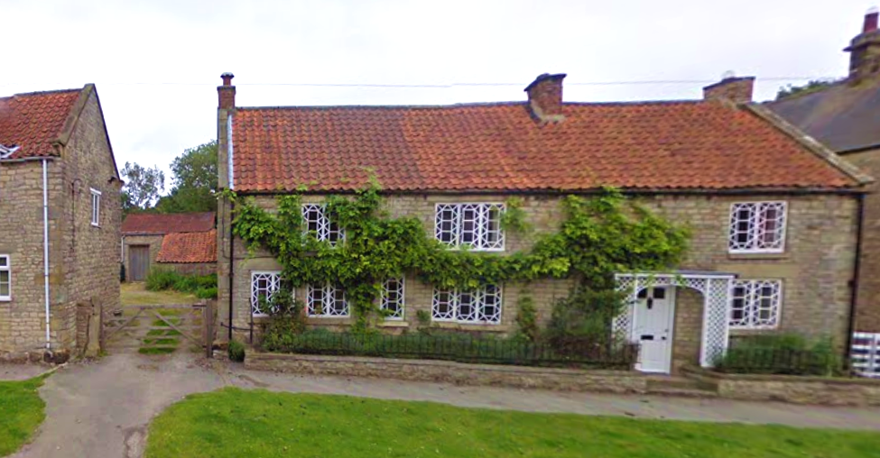

Figure 26. Glimpses in-between buildings to agricultural buildings beyond add to
the character of Appleton-le-Moors

Figure 25. Key views around the Conservation Area. Red – long distance, Green - short distance views.
© Crown copyright 2017. All rights reserved. Licence number 100042279

9.0 The historic buildings of Appleton-le-Moors
In a nutshell: stone buildings, one to three storeys high; red pantile roofs, some slate, stone water tabling, chimneys in brick or stone, stone kneelers, traditional window types, few porches, thick stone lintels over windows and doors, stone quoins to larger properties. One traditional shop front.
The 12th Century planned form of Appleton-le-Moors laid out the village in tofts and crofts, east to west of Headlands Road. Eastern and western garths around c.330ft long were created, forming the distinguishable linear pattern of the village seen today. Towards the 19th Century the development and strong linear formation of the village was well under way. There was little space in-between buildings so development built outwards towards the rear of the site and into the garths. This has created glimpses of agricultural outbuildings in between buildings and out into rear farmyards.
Little has changed to the village of Appleton-le-Moors in the past 100 years. The village maintains a strong linear form of 18th and 19th Century stone-built houses and cottages, with outbuildings to the rear (some facing the roadside). Sturdy stone buildings of one and two storeys high (under a red pantile roof) dominate the roadside with thick stone lintels above doors and windows. The stone of the village is sandstone but takes on a grey appearance in the winter months.
The buildings attributed to Victorian Philanthropist Jospeh Shepherd and his legacy stand out the most in the village. Most have slate roofs and a distinctively Victorian Gothic Architectural setting. Appleton Hall was re-built to the wishes of Joseph Shepherd three stories high in the Italianate architectural fashion popular in the Early Victorian era. It dominates the top of the village in height and design and is far more elaborate than the rest of the village. Unusually, it is not a listed building.
Christ Church was built in 1863-65 by J.L. Pearson on the instructions of Mrs Shepherd as a memorial for her husband. The Church is grade 1 listed and has a distinct French Gothic style and is built in local limestone with beautiful pink classical decorations round the walls and the pulpit. Its 90 foot high pyramid spire is a prominent feature in the landscape and can be seen from most key views in the Conservation Area. It contains Rosedale ironstone banding and decorative motifs throughout its interior details. It has a 3-bay aisled nave with narthex, apsidal chancel, mortuary chapel to north and square south-east tower. Lancet windows throughout except for a rose window in the west gable. A string course runs around the nave, chancel and chapel at the west door impost level. Ashlar bands and a band of sunk quatrefoils at springing level of the nave windows.
A well-head of 1865 sits in the wall to the churchyard and contains the grade 2 listed war memorial. The memorial tablet is incorporated within a pleasingly executed well-head in the medieval style and is contemporary with the church and vicarage of 1865.
The neighbouring Parsonage Mullion Court St Marys (now 2 dwellings) was again built by the renowned Architect JL Pearson 1865 under the patronage of Mrs Shepherd. The building was partly rebuilt in 1931 after a fire, but it can still be easily attributed to J L Pearson. The building matched Christ Church with Dressed limestone with ashlar dressings including decorative banding. It is in the High Victorian Gothic style with pointed arch 3-light mullion windows and a Gothic Arch doorway. The building is grade 2 listed and forms a cohesive landscape setting with the Church.
The Village Hall and attached house (formerly the School and School Masters House) was built in 1865 also by J L Pearson. It is grade 2 listed and again has elements of the Victorian Gothic style but also leans on the Arts and Crafts persuasion, with it having the upper storey jettied and timber-framed with a half-hipped gable.
To the top of the village is the Wayside cross (Low Cross; grade 2 listed). The cross is believed to be Medieval and is a roughly shaped sandstone monolith with a circular hole drilled through it, approximately 1.25 metres high. This correlates with the villages continued development over the centuries. Low Cross is also classed as a Scheduled Monument as its Standing stones are believed to have been part of a prehistoric ritual or ceremonial monument (dating between the Late Neolithic to the end of the Bronze Age).
There are 22 listed buildings throughout the Conservation Area and all play a distinctive part in making the village what it is today. To the south end of the village is Manor Farm (grade 2), prominently positioned on the sharp bend onto the Main Street. Manor Farm is a farmhouse with attached dairy and barn to right, and further attached outbuildings to its rear. It is Mid 18thCentury but believed to had earlier origins. It consists of Dressed limestone with sandstone dressings under a pantile roof with brick stacks. Of particular interest is the Cruck-framed barn to right, with coursed rubble walls and pantile roof.
As at Manor Farm and Rose Marie Lodge (both grade 2 listed) there is evidence of earlier 17th/16th Century buildings around the village. At this time, it is likely that most buildings would have been constructed in timber and wattle and daub with roofs of heather thatch harvested from the surrounding moors. As timber became more difficult to obtain due to taxes and restrictions, building materials progressed to stone and brick, which lead to the encasing of many timber framed buildings.

Figure 26. Listed buildings in the Conservation Area (blue), not including curtilage.
© Crown copyright 2017. All rights reserved. Licence number 100042279

9.1 Doors
The character of the Conservation Area is enhanced by its retention of traditional timber doors on its cottages and villas. Colours tend to consist of traditional tones of white and cream but there are some earth tones such as sage green, blue-grey, browns, deep reds, dark green and blue reflecting the villages Victorian character. Pastel colours are not that common, and neither are the more modern colour palettes. Most doors are central to the property’s facade, with their designs being traditional 4 or 6 panelled timber doors (some half glazed), with batten doors to agricultural buildings. Fanlights and over lights are un-common and exist on the larger village houses of the Victoria era. Door knockers are varied but many are on a traditional theme in Brass or Pewter. Few porches exist, the most notable being at Appleton Hall (which has a strong Italianate form) and Burlingham House which has a distinctive grand stone portico, believed to have come from the Hall.
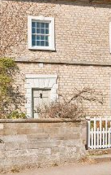
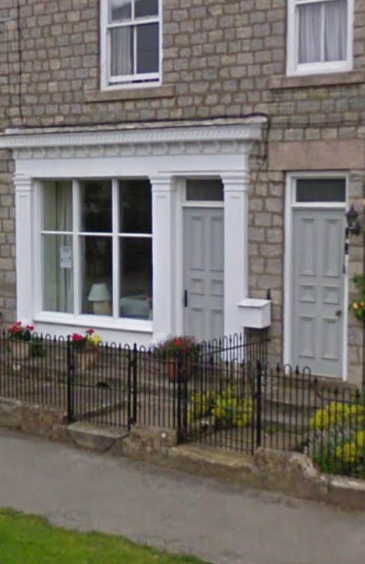
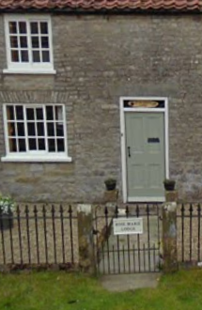
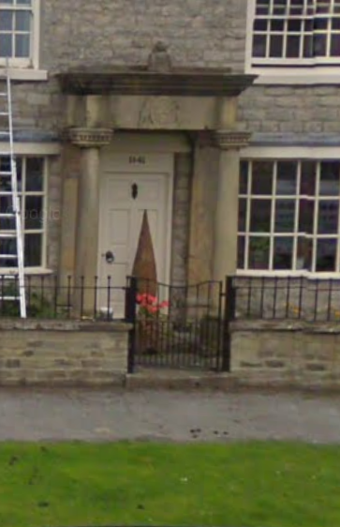
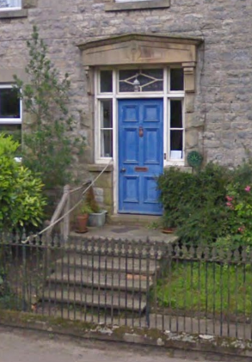
Date stones are rare and can be found above some doorways. Some properties are accessed via stone steps with ornate early 20th Century iron railings (some with boot scrapers on the top step).
Figures 32 – 36. A selection of the different door designs in Appleton-le-Moors.
Special mention to decorative stone door frames and hood moulds on the larger properties incorporating elaborate designs. However, they are small and simple in scale on the cottages and older properties and do not dominate the appearance of the building. Over time a series of permanent and semi-permanent porches have been introduced, but they are not a regular feature.
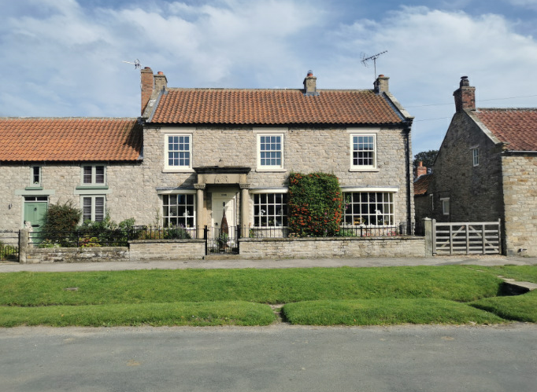

Fig 37: Burlingham House with its elaborate portico from Appleton Hall

9.2 Windows
Traditional windows feature strongly thanks to the Article 4 Direction that covers the village and protects the changing of windows. Traditional sashes (Yorkshire sliding and vertical box sashes) are prominent in the village especially on the listed buildings. These add greatly to the character of the Conservation Area and retain the historic charm of the houses. There are however some modern replacements in a faux sash or casement variety. The Victorian four pane sash window are also in evidence and feature prominently with cylinder glass. There are few cantered bay windows in the village, but mainly on the Victorian residences.
Windows are predominantly painted in white or cream under thick stone lintels. The former methodist chapel has typical margin light coloured glass windows seen in Victorian/Edwardian buildings and makes a positive contribution to the street-scene. Rosemarie Lodge (grade 2 listed) is a fine example of the locally vernacular of Yorkshire sliding sashes.
J.L Pearson stamped his architectural mark on the village of Appleton-le-Moors, through the use of 19th Century High Victorian Gothic features such as the rose window in the western gable of Christ Church and the tall, three light window, with geometric tracery in the school, now Village Hall. Believed to be taken from the previous school (the Parsonage), now 2 dwelling houses, this was an act of village tradition. Other window details to note include the unique form of the art deco inspired white metal casement windows with ½ diamond head glazing bars located at Butterstone Cottage, with matching porch and the decorative stained glass of the Wesleyan Methodist Chapel.
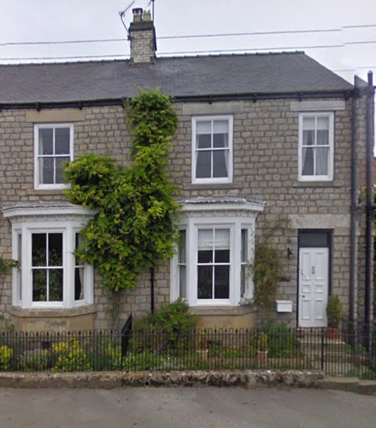
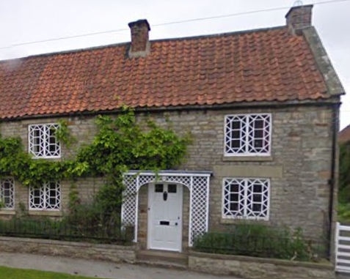
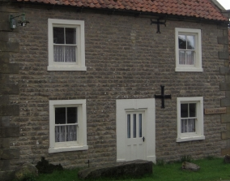
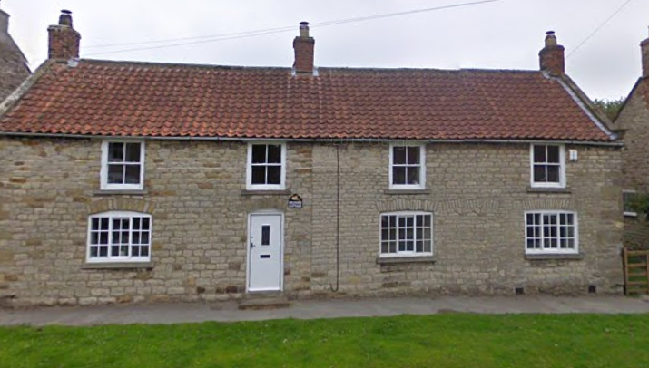
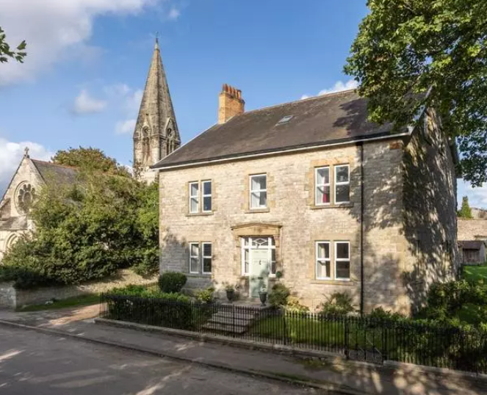
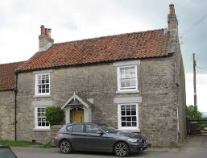
Figures 38 – 43. A selection of the window designs found in Appleton-le-Moors.

Signs of past economic and commercial viability within the village can be seen in the shop front window elevation of Chapel Garth. An existing shop front remains, thought to be the trading premises once occupied by a grocers and tailor for the village. A mixture of handmade glass can also be seen throughout the village, with its imperfect distorted appearance positively adding to the character of the streetscape.
Other interesting features include that of the Listed Building ‘Village Street (west side) East View’, opposite Bluebell cottage, in which the upper centre window is falsified, deceiving to the eye, predictably an infill of a previous opening. Bow and bay windows are also found within the Conservation Area. Not typical vernacular, these do positively contribute to the character area, demonstrating different periods of development particularly in Burlingham House, Chapel Garth - Lingmoor and Appleton House.
White window surrounds are characteristic of the area set back into reveals in order to add definition. Most buildings are finished with stone lintels and sills however some surrounds are of timber or raised with decorative stone finishes such as triple keystones. Wall dormers do not feature heavily in the Conservation Area and should be resisted as they do not reflect the local vernacular of the village.

9.3 Shop Fronts
There is only one shop front in Appleton-le-Moors which has now been converted into a dwelling. The shop front appears to be early 20th century with a dentilled eaves, 6 panelled door, fanlight, fascia, plinth, pilaster and corbels. It is a particularly fine well restored example of the past nature of the building and should be retained at all costs.
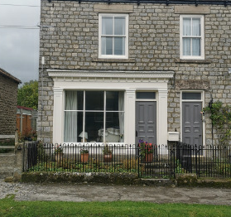

Figure 44: The only shop front in the village.

9.4 The little details
In a nutshell: Door furniture, stone steps, gravel paths, stone gate posts, date stones, timber framing.
The accumulation of little things throughout the Conservation Area can make a big impact on its setting. Historic doors that have been retained often still have their brass door knobs, cast iron knockers and letter boxes, these all add greatly to the historic charm of a door. In front of most doorways in the Conservation Area are Yorkstone paths and steps. Most of these have been well worn with inhabitants crossing the threshold over the decades, these however, add to the character of the dwelling. At the end of many of these pathways are 2 stone gate posts, framing the doorway to the property. Many of these have a simple timber or cast-iron garden gates attached to them and add greatly to the character of the village.
In between buildings and leading to rear outbuildings and barns is a series of natural pathways, some using gravel. Permeable surface treatments should always be favoured over impermeable ones, such as tarmac, (for these smaller routes and driveways) which can urbanise an area. There is a lack of stone granary steps in the village however the most notable are on the barn attached to Gath End. This building makes a positive contribution to the street-scene and its historic charm and character should be retained at all costs.

9.8 Considerable significance
- Worn steps to doorways.
- Historic Door Furniture
- Date Stones
- Stone Gate Posts

9.9 Some significance
- Gravel pathways
- Timber gates and fences

9.10 Opportunities to conserve and enhance
- The loss of minor historic features can cause harm to the historic interest of a Conservation Area and so they should be actively managed.
- Retention of traditional door furniture
- Removal of tarmac driveways for gravel (a permeable surface treatment)
- Removal of modern styles of door furniture and replacement with a traditional style

10.0 Recommendations for future management

10.1 Conserving and Enhancing the Street Plan, the Surfaces, Open Spaces and Boundaries of the Conservation Area
- Retain the narrow lanes and traditional surfaces of flags; work with statutory undertakers and utilities to replace surfaces with traditional materials.
- Limit boundary types to stone retaining walls, softened with plants and visually permeable materials such as wrought or cast iron fencing, post and rail or picket fencing.
- Manage tree cover to ensure longevity
- Maintain the crofts and former burgage plots and limit the amount of back of plot development
- Ensure advertisements and signage are traditional and in-keeping with the character of Appleton-le-Moors by using hand painted timber signs and the minimum needed to advertise the business.

10.2 Conserving and enhancing the archaeology of the Conservation Area
- In line with National Planning Policy, alterations to historic buildings should be informed by a Statement of Significance and ground disturbance may need to be archaeologically recorded. A Heritage Statement may need to consider the impact of new development on sub surface remains.
Conserving and Enhancing the Vistas and Views of the Conservation Area.
- Red pantile should be considered the norm for future roofing materials on new development so that views into the village continue to be a mix of green trees and red roofs.
- Chimney stacks should be retained.
- Any development should reflect the height and massing of the surrounding buildings and not cover over any key views
- The view of the spire of Christ Church can be seen around the Conservation Area, and view lines should be preserved
- The channelled view created by linear development up Headlands Road should be retained.
- Views in-between dwellings towards open countryside and agricultural buildings should not be interrupted

10.3 Conserving and enhancing the historic buildings of the Conservation Area
- New building stock should remain modest in scale and retain the settlement pattern.
- Sandstone and red pantile are the characteristic building materials that should be visible in any view.
- Pitched roofs are characteristic and flat roofs would be a negative feature.
- Dormer windows are not characteristic and should be resisted.
- Chimney stacks should be retained, log burner flues should go through existing chimney stacks.
- There is a wealth of traditional window types to choose from if new development is proposed, existing traditional windows should be retained so that the variety is conserved, and distinctive original crown and cylinder glass preserved too.
- Traditional shop windows should be conserved and restored.
- Rooflights should be to the rear of buildings and be of the traditional top hung Conservation Rooflight type, flush with the roof.
- A variety of iron or brass door knockers also adds to the architectural interest.
- Where traditional doors survive these should be repaired and retained as they add greatly to the patina of the street-scene,
- There is some evidence of 20th century cementitious pointing that is damaging to the stonework; in due course, this pointing should be replaced with non-hydraulic lime to avoid permanent damage.
- Agricultural outbuildings should be conserved in a manner appropriate to their character and setting. Any changes to them should remain minimal and should still maintain their agricultural and humble appearance.

10.4 Conserving and enhancing the little architectural and historic details
- The loss of minor historic features can cause harm to the historic interest of a Conservation Area and so they should be actively managed.
- Evidence of the agricultural nature of the village should be retained.
- Drain pipes and guttering should be in cast iron.
- Redundant features such as former standpipes, boot scrapers and mooring rings should be retained wherever possible.
- Door furniture where historic should be retained and repaired

10.5 Recommended boundary changes
There are no recommended boundary changes to the Appleton-le-Moors Conservation Area. On the whole there has been very little new development in or around the village which would merit its changing.

11.0 Conclusion
Appleton-le-Moors Conservation Area was designated in 1977 for its architectural and historic interest. Its special interest derives from its Medieval planned form of crofts and tofts and its humble moorland character with stone built cottages and larger Victorian villas running along a linear street-scene. Agricultural buildings and outbuildings to rear of properties adhere to the rural nature of the village and add to the setting of the Conservation Area. Whilst the street layout has its origins in the Medieval the buildings are predominantly 19th century in appearance and built of stone with red pantile pitched roofs and some Welsh slate (mainly on municipal buildings). Dormer windows are not a feature and they do not make a positive contribution towards the roofscape. Stone water tabling, chimneys and the uniformity of roof heights brought about by the linear nature and strong build line of the village reinforces the Conservation Areas character. Many doors are in traditional colours with brass door knockers and the occasional surviving boot scraper. Door canopies are rare but those that to survive are of a grand variety in stone or of a small, humble, timber variety. Views between the properties give glimpses down crofts to traditional outbuildings and frame views out to the Vale of York/Pickering.
The management plan makes a number of recommendations designed to help and conserve these special qualities. In short, such as, keeping the scale and design of new development in harmony with the special qualities of the Conservation Area, the preservation and repair of historic materials, the retention of historic openings on buildings and the ‘open’ nature across the boundaries of the Conservation Area. The type of materials for all new development should match closely with those prevalent in the Conservation Area already and care should be sought to try and match stonework with geographical locations.

12.0 Appendix and Acknowledgements
Allerston, Pamela, (1970). “English Village Development: Findings from the Pickering District of North Yorkshire” The Royal Geographical Society (with the Institute of British Geographers). no 51, 95-109.
Allison, Margaret (2003). History of Appleton-le-Moors. A 12th Century Planned Village. 1st edn,
Bulmer (1890) History and Directory of North Yorkshire
Hayes, Raymond and Hurst Joseph (1989). A History of Hutton le Hole. North York Moors National Park.
Historic England (2019) Advice Note 1 Conservation Area Appraisal, Designation and Management
National Planning Policy Framework (2024)
North York Moors Local Plan (July2020)
Planning (Listed Buildings & Conservation Areas) Act 1990 (69, 70, 71 & 72)
Pevsner, N (1966) The Buildings of England. Yorkshire and the North Riding
Royal Commission (1987). Houses of the North York Moors. Royal Commission.
The Town and Country Planning (Development Management Procedure) (England) Order 2015

13.0 Management overview
Development Management
The Local Planning Authority are dedicated to managing Conservation Areas in accordance with the above detailed Planning Policy and Legislation. Development in a Conservation Area is controlled under the requirements of the General Permitted Developments Orders, Town and Country Planning Act 1990, Town and County Planning (Control of Advertisements) Regulations 2007 and the Planning (Listed Buildings and Conservation Areas) Act 1990. Advise on development within a conservation area is available on the Authority’s website. It is also recommended to submit a ‘pre-planning application’ to determine if planning permission is needed and any constraints upon development, before submitting an application. Planning Enquiries can be sent to planning@northyorkmoors.org.uk.
Archaeology
Developments on a small and large scale have the potential to impact upon archaeological remains. Any application for development will be subject to meeting archaeological requirements in the submission, determination and post-decision periods. The Authority’s Historic Environment Records and their specialist archaeological advice team can be found on the North York Moors National Park Authority Website.
Enquiries can be sent to: conservation@northyorkmoors.org.uk.
Nature Conservation and Wildlife
The Authority will determine applications for development in accordance with the Hedgerow Regulations 1997, The Conservation of Habitats and Species Regulations 2017, section 15 of the NPPF (Conserving and enhancing the natural environment).
Enquiries can be sent to: conservation@northyorkmoors.org.uk.
Trees
Trees in the Conservation Area are protected by the designation where they have a stem diameter greater than 75mm (3 inches) when measured at 1.5 metres (5 feet) above ground level. Anyone wishing to prune or remove a tree must seek the necessary permissions from the Authority. Enquiries can be sent to: conservation@northyorkmoors.org.uk.
Building Conservation
The current Conservation Area is covered by an Article 4 Direction, for further details on what this covers please find it on the website northyorkmoors.org.uk, or email the Building Conservation Team. The building Conservation team provide specialist advise on development to listed buildings and within Conservation Area. General enquiries can be sent to building@northyorkmoors.org.uk and applications for specialist pre-application advice can be submitted via the Authority’s website. Information on Conservation Areas www.northyorkmoors.org.uk.

https://historicengland.org.uk/listing/what-is-designation/local/conservation-areas/ [accessed 22.12.2016]
Margaret Allison, History of Appleton-le-Moors. A 12th Century Planned Village (2003): 9.
Ibid: 18.
Margaret Allison, History of Appleton-le-Moors. A 12th Century Planned Village (2003): 107-108.
Ibid: 42.
Margaret Allison, History of Appleton-le-Moors. A 12th Century Planned Village (2003): 153.

