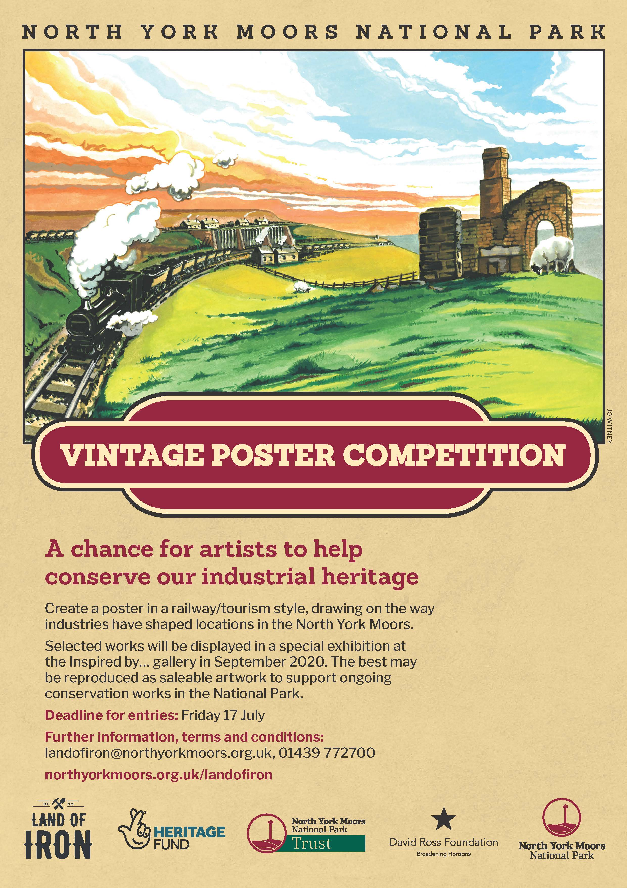

COMPETITION BRIEF – MARCH 2020
Contents:
1 – Introduction
2 – Entry criteria and procedure
3 – Judging procedure, exhibition and sale of original artwork
4 – Reproduction and future sale of artwork

1 – Introduction

The North York Moors has a rich industrial heritage that has left us with iconic monuments and fascinating stories. The Land of Iron project has celebrated this heritage by conserving and opening up access to many of these historic sites, and telling these stories through interpretation, exhibitions and events. The project has also recruited a small army of volunteers and developed a series of management plans to help care for this heritage long into the future.

The Vintage Poster Competition has been conceived to promote this heritage further still and also help support its ongoing care. We are looking for a range of vintage and railway poster-style artworks that convey the wonder of these industrial heritage stories, the monuments that have been left behind, and the nature that has reclaimed the landscape since the industry left.

It is anticipated that a number of the winning entries can be developed into a range of saleable artworks (posters, framed prints, card and postcards etc.) that people will want to own. The profit from the sale of these products will be used by the National Park Authority to support the volunteers and ongoing conservation of this heritage, to help secure it for future generations to enjoy – art supporting heritage conservation.

This brief is intended as a guide for potential entrants to the competition – outlining what it aims to achieve, the criteria for entries, how the artwork will be judged and exhibited, and what will happen with the ongoing reproduction of artwork. For any queries or to discuss the competition further please contact the Land of Iron team on landofiron@northyorkmoors.org.uk or 01439 772700.

2 – Entry criteria and procedure

The requirements for entry are as follows:

- Entries must convey something about the industrial heritage of the North York Moors. This could be ironstone, other extractive industries such as coal, jet and alum, or other industrial heritage such as railways, glass making or rural crafts. It could also be past, present or future with the heritage operational or long since reclaimed by nature. It could be related to people, industry, landscape, wildlife, geology, transport, or other themes.
- Entries should reflect a vintage style inspired by the railway posters of the early-mid 20th century.

- Artwork must be of A3 size (297 x 420 mm). Either portrait or landscape format is acceptable. Winning artwork will be displayed at A3 size in the Gallery so should be appropriate for this size of reproduction/display.

- Artwork can be of any media, and physical or digital form, but must be 2D.

- Entries should be submitted as digital copies/photographs of the original artwork in jpg or pdf format under 10Mb in size, to landofiron@northyorkmoors.org.uk, along with the provided application form containing the name, address, phone number and email of the entrant.

- Entrants may submit one entry each.

- There is no cost to enter the competition.

- Any age or ability is welcome. More important is creativity, impact and meaning.

- The competition opens for entries on 1 March 2020 and closes at 1.00pm on Friday 17 July. Entries before or after this window will not be accepted.

3 – Judging procedure, exhibition and sale of original artwork

The process for judging digital entries, preparing for and delivering to the exhibition is as follows:

- All entries will be assessed by a selection panel on 29 July 2020, and a number of winners selected.

- Winners will then be contacted to arrange for their original artwork to be delivered to the Inspired by… Gallery on Wednesday 2 September between 1pm – 3pm, where it will be displayed at the exhibition 5 – 25 September 2020.

- Entries not selected for the exhibition will be notified by email.

- Prior to delivery, all original artwork is to be placed within a black frame with ‘D’ rings fitted for hanging. Full terms and conditions for the exhibition of original artwork will be sent with the invitation to exhibit.

- All original artwork should be signed by the artist and labelled as appropriate. For labelling guidelines please see this example.

- All winners will be invited to a Meet the Artist event on Saturday 5 September 2pm – 4pm.

- The original artwork can be sold at the exhibition, at a price agreed with the artist, and on the Gallery’s standard terms and commission rates.

- Any unsold artwork must be collect by the artist at the end of the exhibition on 6 October between 10am – 12pm.

4 – Reproduction and future sale of artwork

The North York Moors National Park Authority (NYMNPA) may wish to reproduce a number of the winning artworks as posters, cards, framed prints etc. to support the ongoing conservation of local industrial heritage.

The process for this will be as follows:

- It is expected that all work submitted is original and that copyright will be given by the artist free of charge to the NYMNPA to support the ethos of the competition. Rights to reproduce this artwork will be maintained by NYMNPA for 3 years.

- Artists will be contacted to discuss publicity and artist recognition. It is envisaged that artists will be publicly recognised for their charitable contribution towards heritage conservation.

- A legal agreement will be drawn up between the artist and NYMNPA to accommodate the above agreed terms and set out an appropriate timescale for review.

Thank you for your interest – art supporting heritage conservation.

