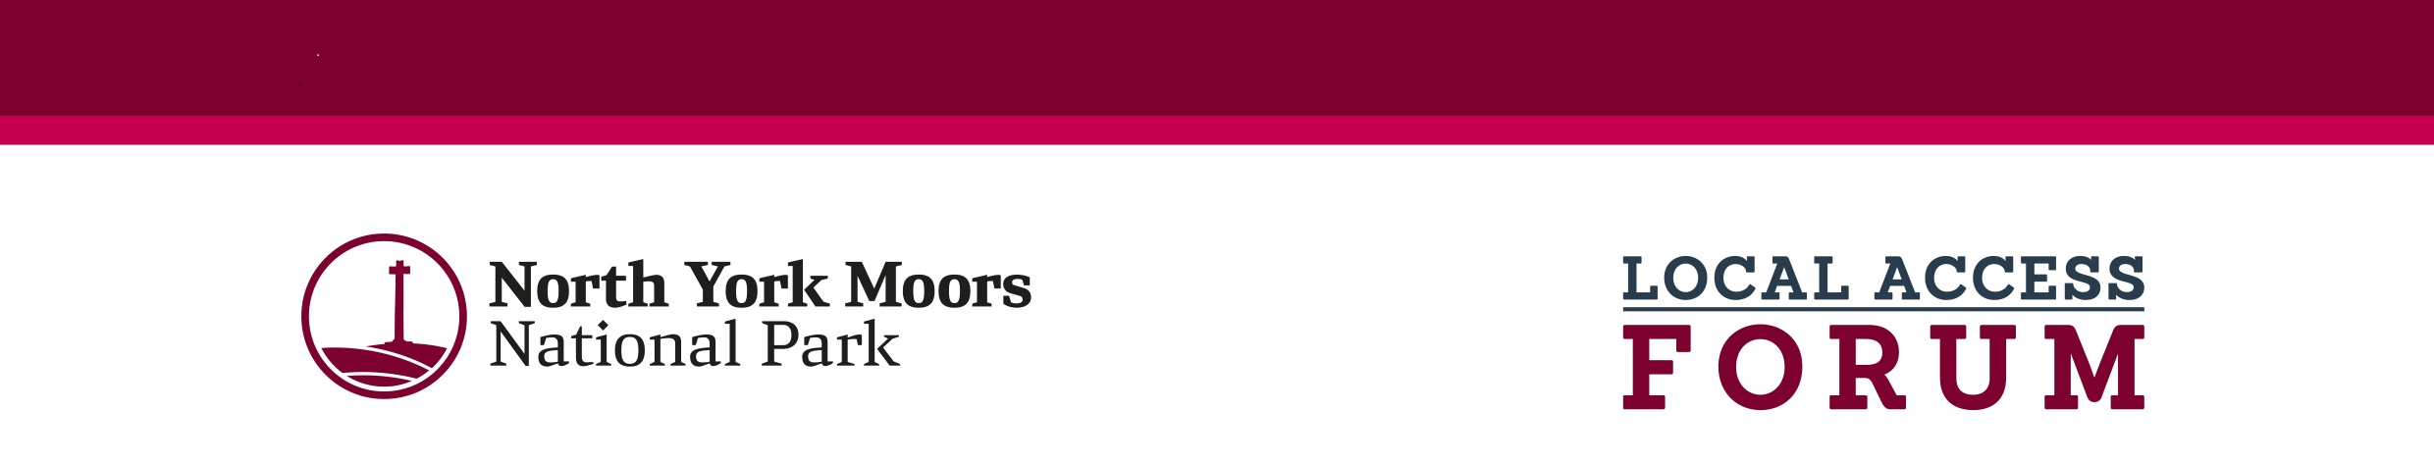

Local Access Forum – General Information
The primary purpose of the Forum is to provide an opportunity for representatives of recreational users, landowners and other interests to advise the National Park Authority on the improvement of public access to land in the National Park for the purpose of open-air recreation and the enjoyment. This should be done in ways that address social, economic and environmental interests, whilst encouraging and assisting access provision. The advice given by the Forum should be of particular local relevance. Agenda items are generally not case specific but could cover issues such as proposals for the definition or management of access land, the imposition of bylaws, long term closure of land, as well as on wider issues considered, for example, in rights of way improvement plans. Regulations prescribe the arrangements for membership, but in broad terms Local Access Forums must have balanced representation of users of access land and rights of way, landowners and occupiers, and other interests especially relevant to the area (see Table 1).
The area represented by the Forum is the whole of the North York Moors National Park, including land in both North Yorkshire and Redcar and Cleveland. Forums have also been established to cover the remainder of Redcar and Cleveland, the Yorkshire Dales National Park and the remainder of North Yorkshire outside national park boundaries.
Further details of the work of the North York Moors LAF including agendas and member profiles can be found on the National Park Authority’s website: https://www.northyorkmoors.org.uk/about-us/rights-of-way/local-access-forum

Membership of the North York Moors Local Access Forum

The National Park Authority adopted the following principles regarding the Local Access Forum:
- The Chair will be appointed from the membership at the AGM.
- Membership will comprise a maximum of 17 members plus Officers and LAF Secretary
- Members must bring a wide range of experience including:
a) RoW/recreational use: walking, horse-riding, cycling, climbing, carriage driving, motor sport
b) Land management: moorland owner/agent/commoner, farm owner/agent/tenant, forestry, game keeping, nature conservation
c) Other interests: heritage, tourism, health, local business, education, transport, and local communities, see table 1.
- Three Forum members will represent other Authorities: The National Park Authority, North Yorkshire Council and Redcar and Cleveland Borough Council.
- The term of appointment is three years.
- The Forum should contain, wherever possible, equal numbers of members ascribed to each of the groups shown in the categories above. Members who have experience in more than one of the categories will be particularly useful.
- Members other than those nominated by NYMNPA, NYC and Redcar & Cleveland BC, will be appointed to the Forum by the National Park Authority via an application process.

Table 1
Member Categories | Number of members
RoW/REC - Recreational use, e.g. walking, horse-riding, cycling, climbing, carriage driving, motor sport | 5 (+ 1 vacancy)
LAND - Land management, e.g. moorland owner/agent/commoner, farm owner/agent/tenant, forestry, game keeping, nature conservation | 4
OTHER - Other interests, e.g. heritage, tourism, health, local business, education, transport, and local communities | 3 (+1 vacancy)
North York Moors National Park Authority member | 1
North Yorkshire Council member | 1
Redcar and Cleveland Unitary Council member | 1
Total | 17

