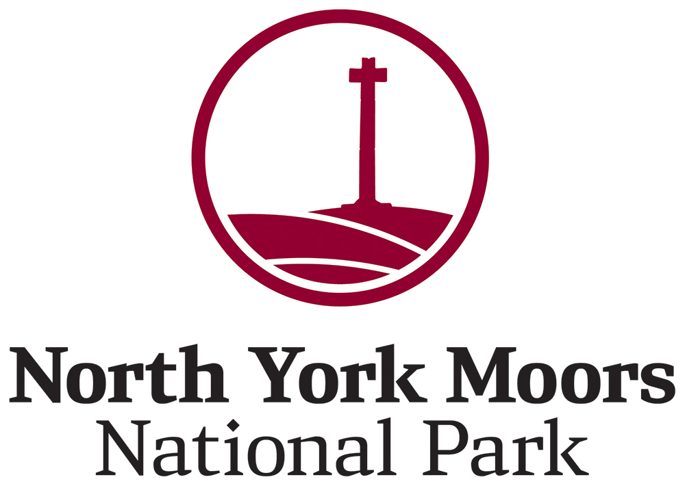

North York Moors National Park Authority

Local Businesses Tourism Contribution

Guidance for applicants

What is the Local Businesses Tourism Contribution?
As a result of the development of the Woodsmith Mine near Whitby, a s106 agreement has been secured to provide compensation and mitigation against any negative impacts on the tourism economy of the North York Moors. One of these contributions is a fund to support local tourism business to develop new products and services that showcase the North York Moors and its special qualities.
The Authority’s Local Businesses Tourism Contribution is designed to support new activity by businesses and organisations that promote the North York Moors area.
We encourage local businesses to apply for funds to aid diversification or possible expansion, particularly activity that extends the season, encouraging off-peak visits.

What kind of project does the contribution support?
Projects must contribute to all of the following priorities:
- Increase awareness of and visits to the North York Moors National Park and/or the wider North York Moors area (and ensure that the North York Moors is referenced as part of the project activity);
- Utilise the North York Moors’ local distinctiveness and special qualities for the benefit of visitors;
- Ensure that any increase in visitors to the area is sustainable, that is activities:
- Must have no adverse impact on the area's tranquillity or the natural and historic environment;
- Must not disturb vulnerable or protected wildlife;
- Should have the support of the local communities relevant to the project.
- Should support the net zero carbon agenda set out by the York and North Yorkshire Local Enterprise Partnership. The following should be considered but is not limited to:
- Should include green/eco products where possible
- Reduce waste diverted to landfill/incineration by reducing, reusing, recycling or testing examples of the circular economy where resources are used again and again, eliminating waste
- If installing new appliances and facilities, incorporate energy efficient solutions where possible
- Reduce food waste: think seasonally; purchase locally; increase meat free menu options
- Reduce transport carbon emissions; promote cycling and walking activities for visitors; increase awareness of public transport use and/or car sharing options
For guidance and benefits to being a sustainable business, the York and North Yorkshire Growth Hub has provided simple toolkits with ideas on cost effective actions that can offer long term benefits.
Any concerns or queries can be discussed with Laura Barr in advance of applying.
- The North York Moors National Park Authority is participating in a VisitBritain/VisitEngland pilot project as part of an ambition to make the UK the most accessible tourism destination in Europe by 2025. If you are a participating business, you may be eligible for funding to develop your business to meet accessibility needs. Please discuss this with Laura Barr in advance of applying.

Eligibility
The North York Moors Tourism Network is working with businesses to find new ways for visitors to appreciate the North York Moors, by creating bookable experiences and activities, and developing new packages and ways to generate more revenue. It is expected that some of these ideas will go on to generate project submissions to this scheme. Therefore priority will be given to those that have joined and are actively participating in the North York Moors Tourism Network.
The contribution is open to individuals, businesses, and other organisations, with priority given to collaborative projects, which will benefit the area as a whole, and those with wider community gains.
Applicants need not be located within the National Park boundaries. Provided that the criteria above are met, and you can demonstrate clear links to the North York Moors and that your project will have a positive impact upon the National Park, the eligible area will be activity that takes place within the North York Moors, Coast & Hills LEADER boundaries 2008-2013.
Work must be completed by 10 April 2022.
Projects must ensure value for money, see Quotes information below.
The funding cannot support repeat activity and should not be considered as long term or core funding.
No funding can be awarded retrospectively so you should ensure no activity commences prior to the funding agreement being signed.

Funding
Contributions will be awarded at the following rates:
- Voluntary sector, not for profit organisations and registered charities – up to 70%
- Collaborative groups (informal or formal e.g. business and trade forums) – up to 70%
- Individual businesses/private individual – up to 50%
You are asked to request a particular contribution value (up to the relevant contribution rate) within the application form. However, please be aware that if a contribution is agreed, it may be at a different value.
The contribution is focused on supporting activity that would not otherwise happen without some financial input. Those that show higher levels of match funding will be looked upon more favourably, especially from individual businesses, as this shows greater commitment and value for money.
In general, awards will not be expected to exceed £10,000.
Higher contribution awards will be considered for exceptional projects and in such circumstances, any contribution request for more than £25,000 may be considered individually by the Authority.
Projects requesting more than £10,000 will require a full business plan to provide more detail on the need for, management and legacy of the proposal.
Contributions can only be claimed once the work has been invoiced and paid for.
Applicants must ensure that they can cash flow their project.

What kind of project does the funding support?
Priority will be given to exceptional and innovative ideas rather than simply the production of standard print material, for example. Here are a few ideas to get you thinking:
- Develop a new event that brings in a new audience to the North York Moors or encourages them to stay longer
- Activity that encourages tourists to visit or stay in the North York Moors during the shoulder seasons
- Integrated and innovative marketing campaigns that attract a new or underrepresented target audience

What can the funding be spent on?
The fund is available to support new or additional activity. Therefore applications must include only activity which is considered 'new', i.e. working with new partners, targeting new markets, developing new products/packages, or new business start-ups.
Existing groups/businesses must ensure their project demonstrates development or progression from previous activity undertaken.
Only marketing costs that support collaborations or new product development will be considered.
Specific expenditure that can be funded (and which must relate to the new activity), includes:
- Content development for a website and social media activity;
- E-marketing e.g. online advertising;
- Printed consumer marketing material e.g. banners or leaflets (which must have a clear distribution plan). In line with the funding's priorities, we will not fund leaflets that appear to be simply listings or advertising;
- Professional support e.g. copywriter, design fees, PR professional;
- Promotional film production;
- Venue hire;
- Monitoring and evaluation of the project.
In kind contributions can be an eligible part of the project finances, costed equivalently as both expenditure and income but should not be used to subsidise existing salaries. Project applicants cannot include their own volunteer time. The rates at which to cost volunteer time are given on the application form.
This list is not exhaustive and many other costs will be eligible, please do ask.

Ineligible costs
You cannot apply for the following:
- Vehicles
- Standard bikes for hire but e-bikes are eligible, where they will serve markets not currently catered for and applicants must maintain that level of service for a minimum of three years.
- Annual core marketing costs e.g. membership fees;
- Planning fees;
- Salaries for existing staff (we will only fund salary costs in exceptional cases and where the costs are real i.e. the salary is not already funded by another income stream);
- Ongoing and normal operational/running costs;
- Reprints of existing promotional literature or simple website upgrades;
- VAT if you are VAT registered, as it is expected that you will be able to reclaim the VAT on purchases made. Therefore, exclude VAT from the costs in the budget. If you are not able to reclaim VAT, then it represents a true cost to you and should be included in the costs;
- Utility costs, e.g. we will not fund costs towards groundworks for utility costs such as electricity and gas;
- Retail spaces – we will only consider retail sites when there is a strong link to the visitor economy.
If you’re seeking funding support to establish a new holiday accommodation site, we strongly advise you discuss your idea with Laura Barr in advance of applying. The grant does not support new accommodation facilities such as shepherds huts, hot tubs or repurposing a building for accommodation use.

Application process
In the first instance, please contact our Product Development and Marketing Executive, Laura Barr (l.barr@northyorkmoors.org.uk) for an informal discussion about your application.
If your project is eligible, you will be sent an application form to complete and return with relevant quotes for work, as detailed within the next section.
It is a competitive assessment process and all eligible projects will be assessed by National Park Authority Officers and verified by the Director of Conservation & Polyhalite Projects.
Applications will be considered throughout the year. However, applications will be dealt with on a first come first served basis and, as the contribution fund is limited, you are strongly advised to submit your form as early as possible.
Assuming that the application is complete upon submission, the Authority will contact you within a month of submission to let you know if you have been successful in obtaining a contribution to your project and the level of funding offered. The decision of the Authority is final and therefore applicants will not have a right of appeal on this decision.

Quotes
You must get at least one quote for every element of the project.
If any single element of the project has a value greater than £2,500, you should obtain three written quotes. You should provide contractors with a written specification of the works proposed. Quotes must be returned clearly marked ‘quotation’ and all opened at the same time in the presence of at least two other people. A written record should be kept summarising all the results, signed and dated by those present. If the lowest quote is not accepted, this must be justified in writing and agreed by the Authority.
Please submit all quotes and other paperwork when sending your completed application form.

Permissions
Please ensure that your project has all the permissions required. These may be from the landowner, Planning Authority (inc. listed buildings consent), Natural England, Environment Agency, Highways Authority, Building Regulations, Church diocese and Historic England etc.

Successful projects
Successful applicants will be sent an agreement to sign detailing the terms and conditions of the contribution. The amount of funding offered to projects will depend on the relevance of the project to the Tourism Contribution’s priorities.
Works carried out before the Agreement is signed cannot be funded.
Where an unforeseen alteration is required to the Agreement e.g. additional costs or a change to the planned expenditure are to be incurred, the National Park Authority will need to review the situation and any amendments to the Agreement will need to be agreed in writing.

Promotional literature and printed materials
Please note that any promotional literature/advertisements/printed material receiving funding must be written and designed by a professional (e.g. copywriter/agency/ freelancer) and be approved by the Authority at draft stage. The cost of professional help should be included within your application. Failure to do so could result in the withdrawal of the contribution.

Acknowledgement of funding
All projects that receive funding are required to acknowledge the support of the North York Moors National Park Authority by including the appropriate logo on all materials produced.
When approving proofs with your design agencies, you are also required to provide the Authority with a copy of the proof to sign off that the logo has been correctly applied.

Claims process
When your project is complete, please contact the Marketing & Communications Team (tourism@northyorkmoors.org.uk) who will send you a claim form.
When submitting the claim, you must provide original receipted invoices for all the funded parts of the project, as well as evidence of payments made such as copies of bank statements.
You can only claim for defrayed expenditure i.e. funding will only be paid out on invoices which have already been paid.
The contribution paid out will be calculated at the percentage rate set out in your contribution agreement. For example, a claim submitted with £1,000 spend at a 50% contribution rate will result in a contribution payment of £500.
As the contribution is calculated as a percentage of your actual spend, if your project spend does not reach the total costs submitted in your application, you may not be able to draw down all the contribution awarded, although we strongly encourage all applicants to meet their total spend targets.
The Authority will accept interim claims, once agreed milestones are achieved, to aid cash flow if necessary.

Contact details
Laura Barr, North York Moors National Park Authority, The Old Vicarage, Bondgate, Helmsley, York YO62 5BP
tourism@northyorkmoors.org.uk
01439 772526

The North York Moors National Park Authority is working with the York and North Yorkshire Local Enterprise Partnership in their ambition to be the UK’s first carbon negative region – carbon* neutral by 2034 and carbon negative by 2040. *Carbon is shorthand for greenhouse gases that cause global warming.
An informal free network created to support tourism/related businesses in/near the North York Moors. More information is available www.northyorkmoorstourism.com/join.html
The area map can be downloaded here: northyorkmoors.org.uk/looking-after/advice-and-grants/local-distinctiveness-and-tourism/leader-map.pdf

